Kick off Meeting
Site visits, 6th-8th March 2019

Marzenego river wetland, Noale (Venice)
Po river delta, Rovigo

Introduction
Iuav University of Venice (IUAV) hosted the first meeting of CREW project partners in Venice, in the day 6th-7th-8th March 2019.
IUAV group organized two site visits for the CREW guests, in order to show to the partners some valuable examples of wetland landscapes and wetland management in the Veneto region.
The first site visit took place in Noale, a small town in the mainland of Venice, where a small wetland area is managed by WWF.
The second site visit brought the CREW group to the Po River delta, localized in proximity of the extreme south of Venice lagoon.

6th March 2019 – Marzenego river wetland in Noale (Venice)
The first site visit has been the very first meeting for the CREW representatives, because it took place in the morning of the first day of KOM.
The participants were: Iuav University of Venice (Maria Chiara Tosi, Marta De Marchi, Michela Pace); Javna Ustanova Za Upravlianjezasticenim Dijelovima Prirode Dubrovacko-Neretvanske Zupanije (Nikolina Djangradovic); Javna Ustanova Natura Histrica (Silvia Buttignoni, Ana Ljiubic); Natura Jadera (Tihana Jurišić, Taida Garibović, Morana Bačić); Città di San Benedetto del Tronto (Sergio Trevisani, Eugenio Anchini). UTI Bassa Friulana and University of Camerino could not be present in the morning as they were still travelling to Venice.
The CREW group met a WWF guide in Noale railway station and, from there, it reached the Oasi Cave di Noale (Pit Oasis of Noale) by feet, as the target area is very close to the city center.
The Oasis has a controlled access all the year long, and it is accessible only under the guidance of WWF volunteers, in fact, they organize site visits for groups and schools, apart from taking care of the area and its life.
The Oasis has a peculiar history. The wetland, in fact, is located along the Marzenego river, that takes its water from a fresh water spring, in the northern part of Pianura Padana plain. The small ponds were excavated during the ‘50s as areas for the extraction of clay, that was transformed into bricks in a factory close by the area. In the ‘70s the clay sources were exhausted and the brick industry started to decline until the complete stop of the production. In the meantime, the area was progressively colonized by pioneering flora and fauna and so, at the end of the ‘70s, a group of sensitive citizens started asking for the protection of this “new” natural area. At the end of the ‘90s the local Water Board (Consorzio di Bonifica) designed a project for the conversion of the area into a constructed wetland for the treatment of nutrients in the water coming from the surrounding fields. The Oasis extends for 20 ha (but it is part of a larger area of 40 ha) and it is a Natura 2000 area, as it is both a ZPS and a SIC area. Today the area is managed by WWF through local funds and maintained by Consorzio di Bonifica. It is possible to access the Oasis strictly in specific periods and hours, and it is forbidden to enter with cars o bicycles. There are two pic-nic areas where it is possible to stop and relax, but in the rest of the wetland it is forbidden to leave garbage or make noises. Despite these strict rules, the Oasis adjoins a sporting area realized without any kind of mitigation green system and where football matches and trainings that cause noise and disturb the fauna. As this area exists since many decades and it was often used as fishing area, it is very difficult to make local citizens and neighbors aware about the importance of respecting and protect the wetland, limiting the accesses. Another controversial aspect concerns the management of the area. WWF, in fact, struggles every year to get some funds to manage and maintain the wetland and its environment, and it also has to periodically renew the management contract with local administrations and authorities. Despite all these difficulties, WWF volunteers guard the Oasis and protect it from possible exploitations, thanks to the collaboration with Consorzio di Bonifica. The Oasis, in fact, is very interesting for naturalists and birdwatchers who come every year to observe plants and animals, and it is an open “classroom” or “laboratory” for scholars and students.
The CREW group had the chance to cross the wetland through the existing circular path, and could see the natural landscape, the hydrophilic vegetation and aquatic fauna. Under the guidance of WWF volunteer Claudia, the participants could discover this wetland, its history, the way it is managed, its fragilities and threats.

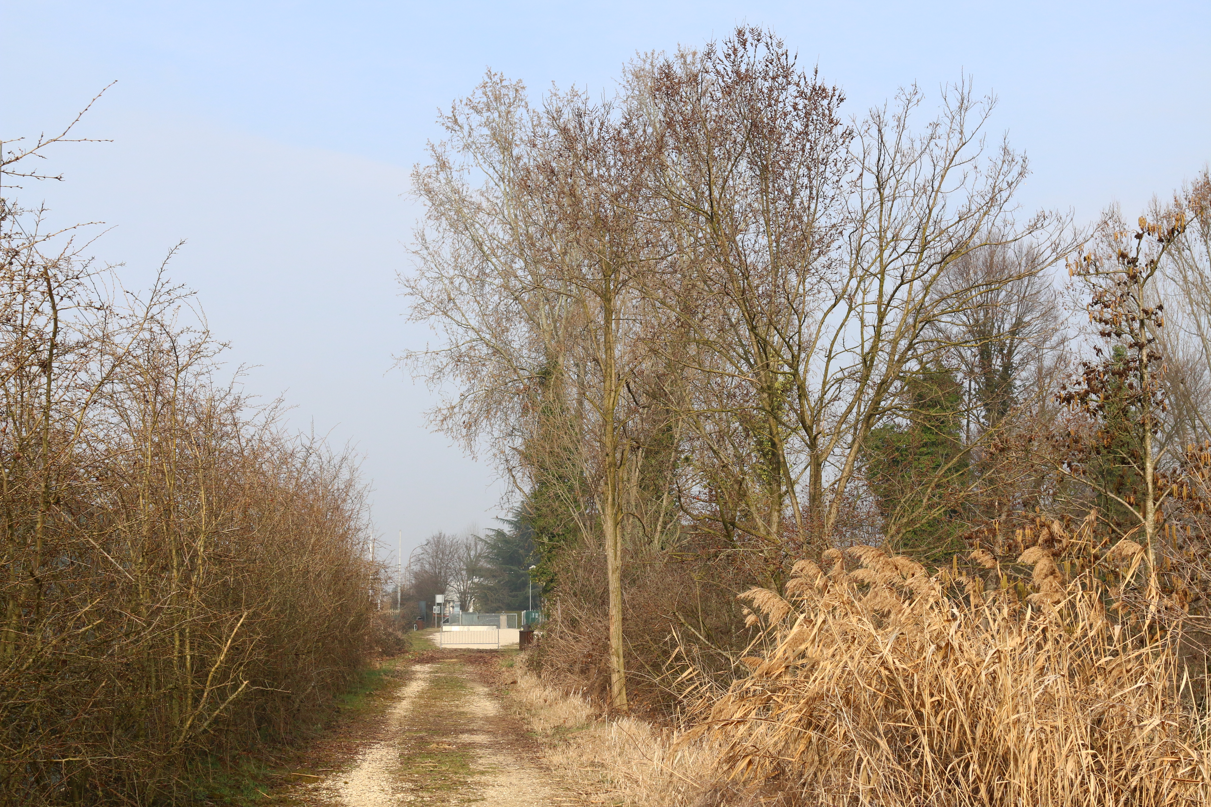 | 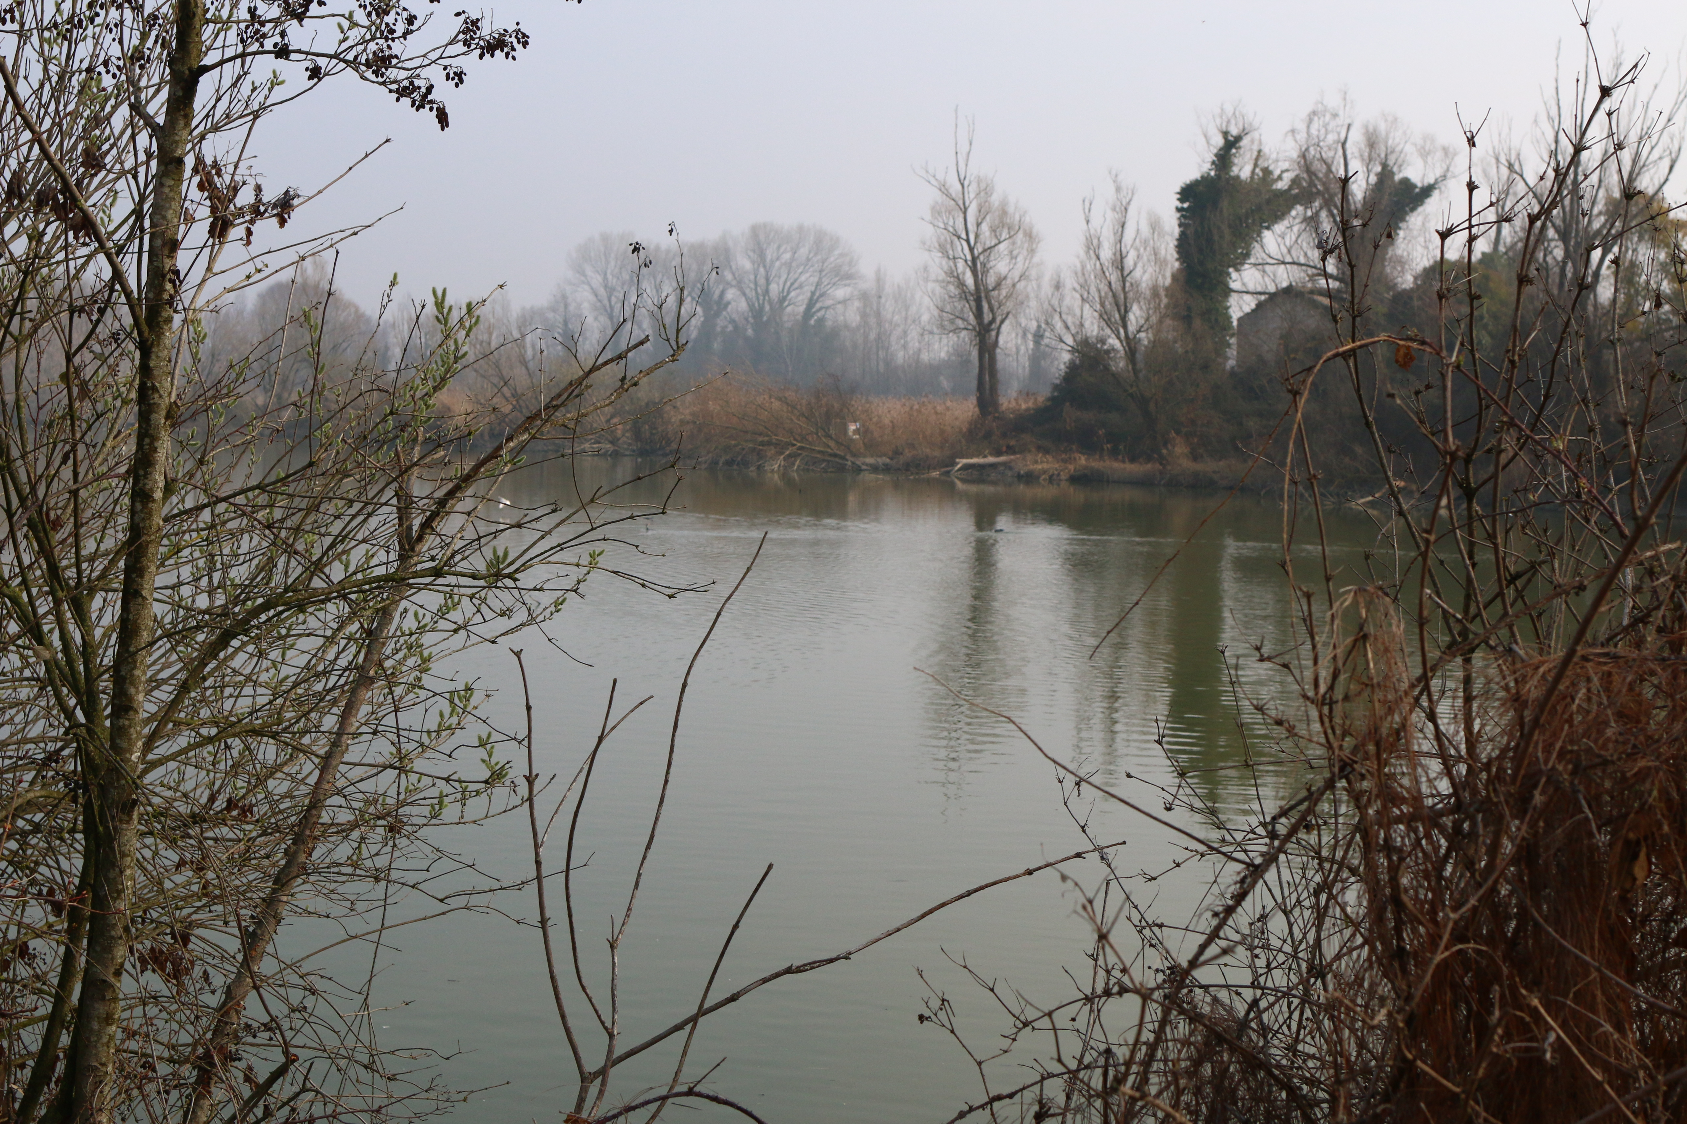
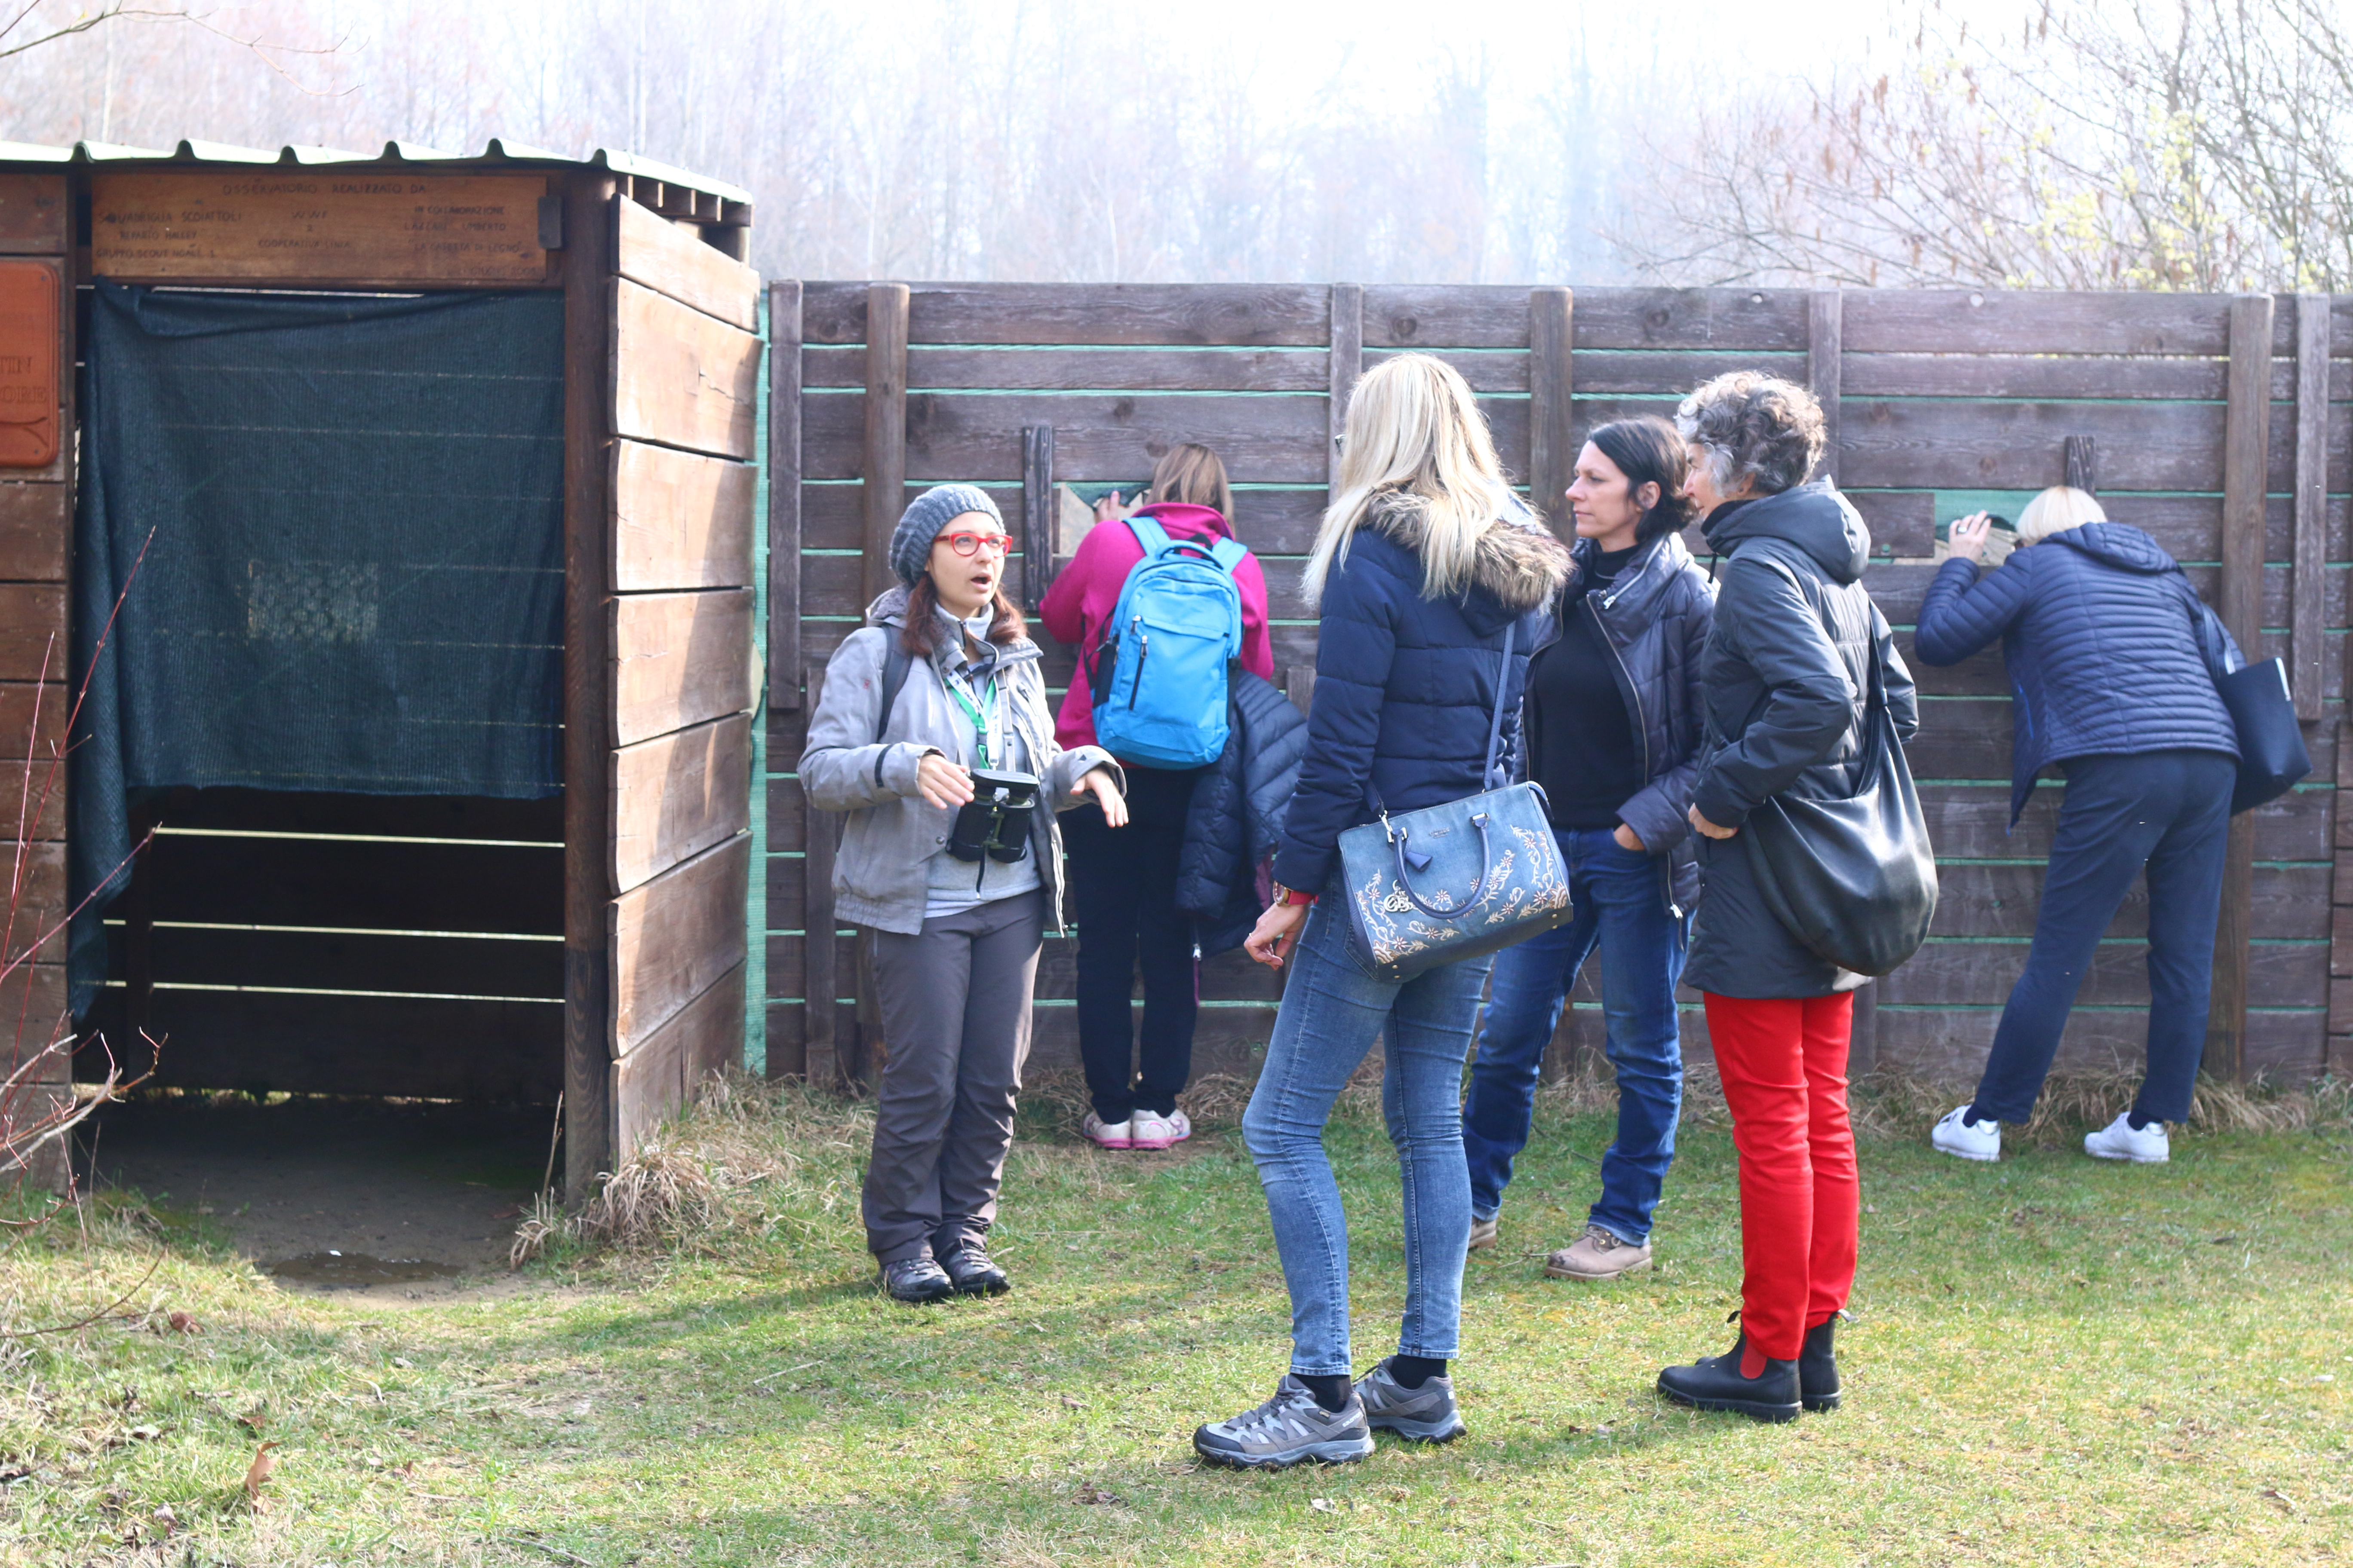 | 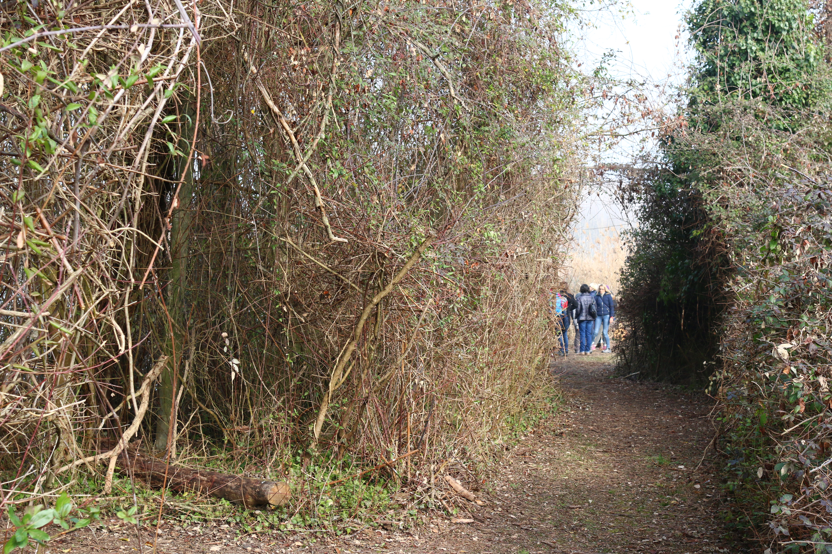
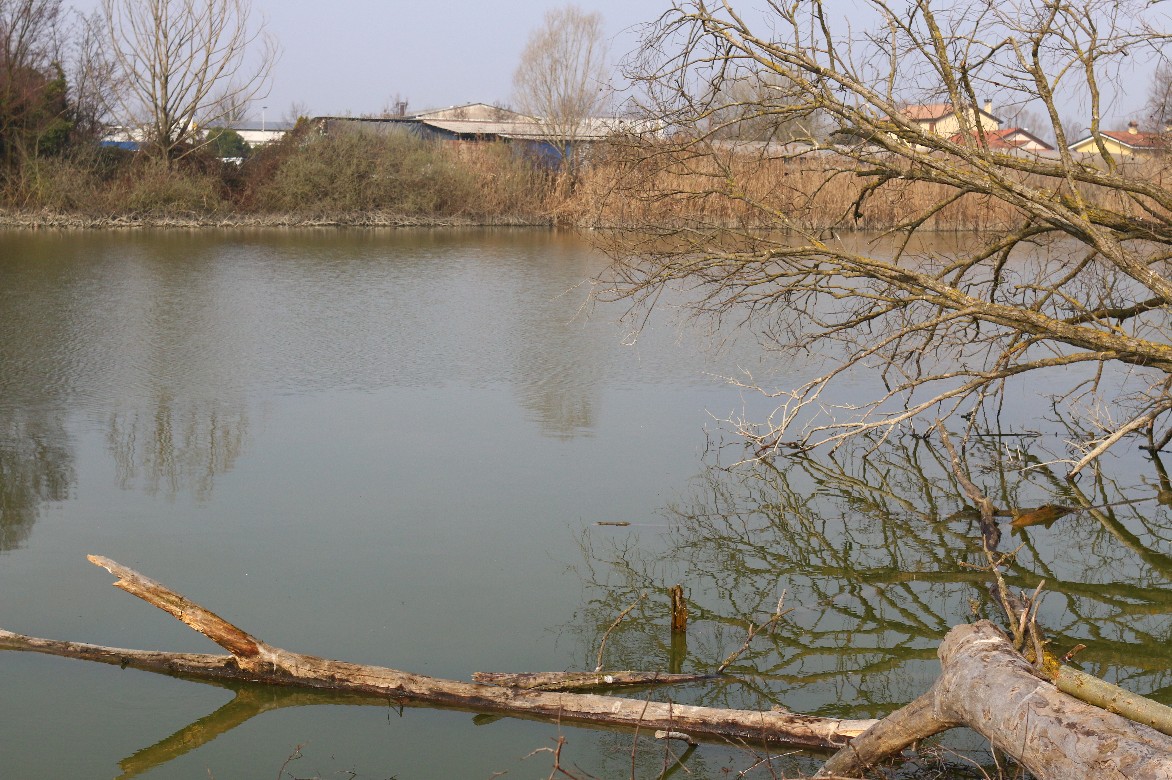 | 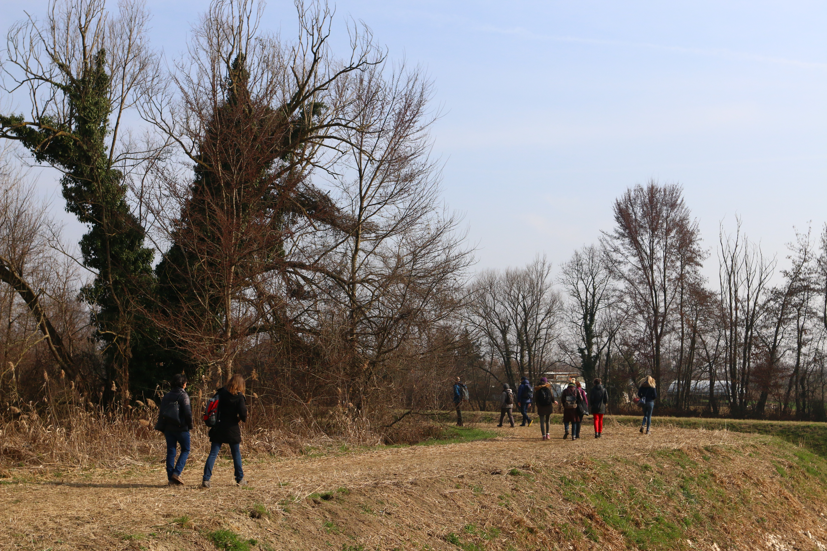

Picture of the Marzenego river wetland in Noale, taken during the fieldwork.

8th March 2019 – Po River delta in Rovigo
The second site visit took place the last day of KOM, and brought the group to the south of Veneto region, in the Province of Rovigo and almost in front of the Adriatic Sea.
The participants were: Iuav University of Venice (Maria Chiara Tosi, Marta De Marchi, Michela Pace); Javna Ustanova Za Upravlianjezasticenim Dijelovima Prirode Dubrovacko-Neretvanske Zupanije (Nikolina Djangradovic); Javna Ustanova Natura Histrica (Silvia Buttignoni, Ana Ljiubic); Natura Jadera (Tihana Jurišić, Taida Garibović, Morana Bačić); Città di San Benedetto del Tronto (Sergio Trevisani, Eugenio Anchini). UTI Bassa Friulana. University of Camerino could not be present as they were travelling back home.

The site visit started at Reclamation Museum of Ca’ Vendramin, in Taglio di Po (Rovigo), a former water pump dated at the end of XIX century, fallen into disuse at the end of the ‘60s. Here the CREW group was welcomed by Sandro Vidali, a local natural guide, and Daniele Grossato, vice mayor of Rosolina municipality. They introduced the main questions of the Po River delta and some issues regarding the management and policy making of the area, telling the story of the Regional Park and the recent Po River Mouth Contract (CFDP).
Sandro Vidali said that the Regional Park was instituted almost twenty years ago, after a first Area Plan, that was actually a top-down solution for the Po delta social and economic problems. The CFDP has been, instead, a new opportunity to put together different stakeholders’ interests.
Daniele Grossato presented the main Po delta characters, explaining the energy cost of maintaining this territory drained. The history of the CFDP started after the 2008 economic crisis, when local stakeholders decided to find a new way to live the territory in a sustainable way. At the national level, the Environment Ministry decided to put the Po River delta in the program for “internal areas” that are usually mountain and isolated areas, because the delta shared with those other areas problems related to depopulation, lack of infrastructures and connections with the outside, difficulties in launching economy and prosperity. Since 2017 local communities, under the guidance of administrations, associations and productive categories representatives, work together to a shared program in order to stimulate the development of the territory. The stakeholders signed a Contract, that includes seven municipalities, for a total amount of 5.000 inhabitants, which main interest axes are school, health and transport, and in a couple of months it would be approved by the Ministry. The National Internal Areas Program promotes collaboration among communities, avoiding any kind of individualism for the common interest; but it also let the local stakeholders to decide autonomously the direction of any new territorial policy, and so the use of money coming from national and communitarian funds. The ambition of the CFDP is, for the period 2021-2027, to find European partners sharing similar territorial conditions and to build a common strategy with.
Sandro Vidali told to the CREW group about the thematic round tables that took place before the redaction of the Contract. One of the first obstacles was the fact that Veneto region inhabitants and entrepreneurs are not used to think in terms of consortia or interest groups, due to the strong individualist approach to the work and the economy. This was the reason why one of the funding lines is related to the promotion of collaboration among enterprises. In this sense, three aspects are facilitated by the Contract funds management: the first one is to create regional enterprises network; the second one is to stimulate the birth of new enterprises, training young people and giving them opportunities to build their own activity in the delta; the third one is to modernize existing touristic facilities, especially the seaside ones, in order to update the touristic offer. First results of this program are expected for the next years.
Mauro Icoviello, from Province of Barletta-Andria-Trani, expressed his interest in the Po delta experience. The concept of Contract, strongly related to water at the beginning, is now growing to the level of territorial planning, making the local requests rise and expressing the needs of municipalities to auto organize themselves.

The site visit continued to the Ca’ Mello Oasis, in Porto Tolle municipality. It is a 30-ha wetland retrofitted by an intervention of the Po delta Water Board during the ‘90s with European funds. The area is the former river mouth of an ancient branch of Po River, detached and drained at the end of the XX century. Until the ‘60s the area was occupied by fields and fishing ponds, and after the 1966, year of the great flood, the ponds were reclaimed and progressively colonized by terrestrial vegetation. In the ‘90s a series of initiatives were taking in order to retrofit the area into a wetland, today inhabited by several species of flora and fauna, and it works as a constructed wetland to treat drainage water coming from the surrounding fields.

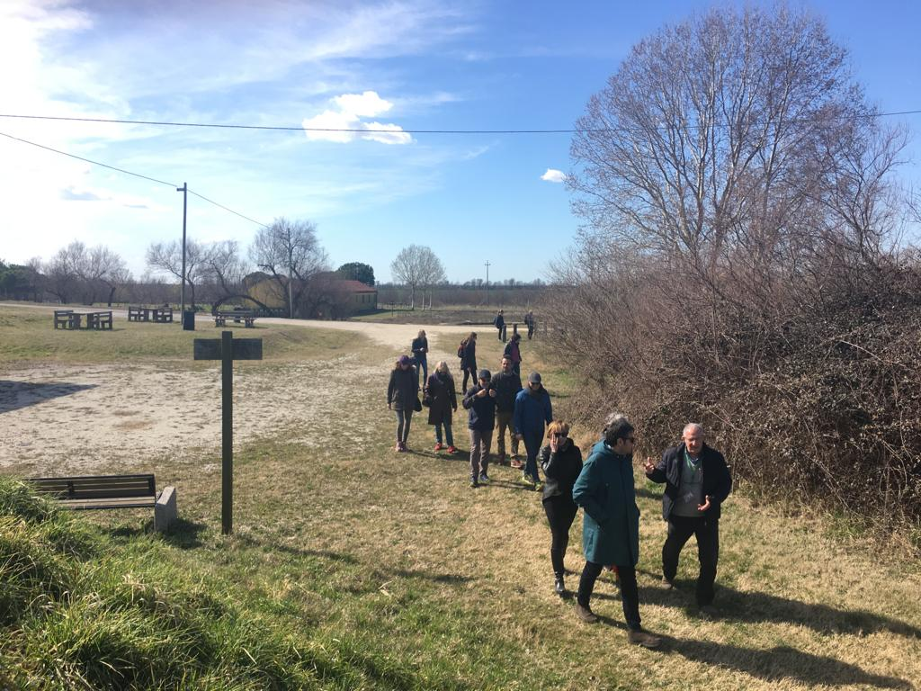 | 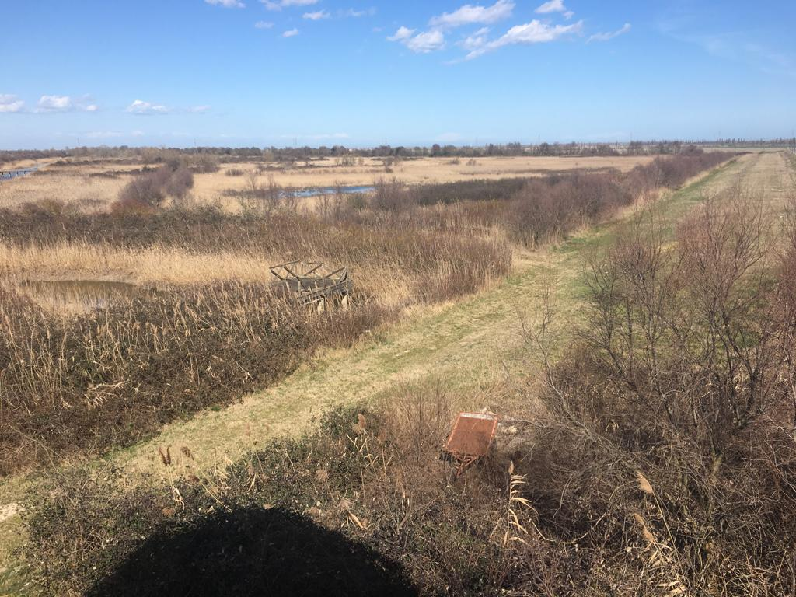
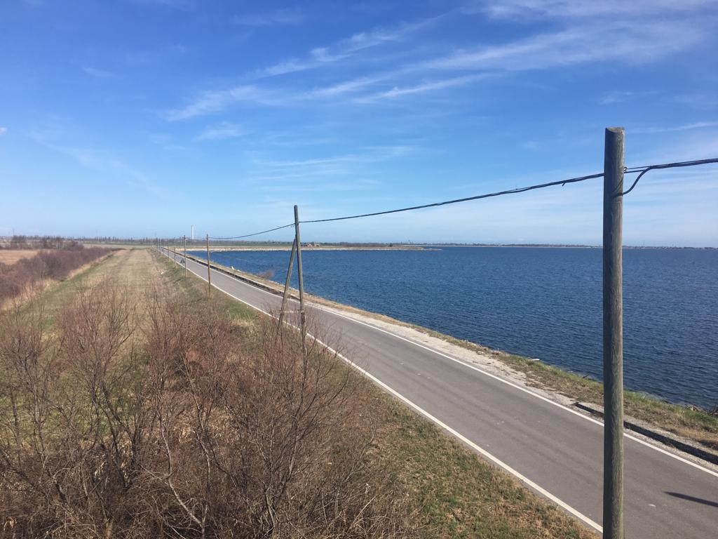 | 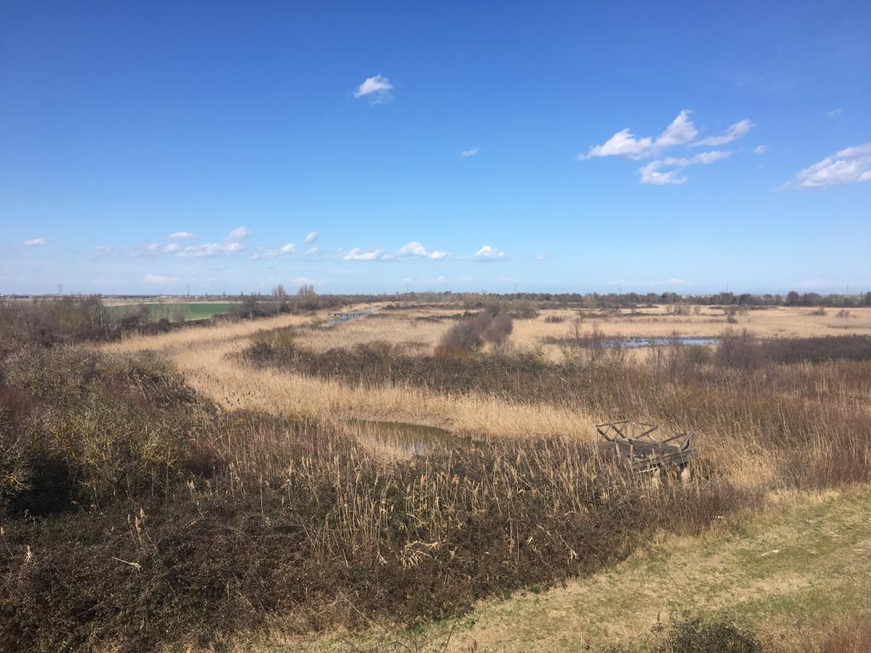

Picture of the Ca’ Mello Oasis in the Po river delta.

Conclusions
The two-site visit gave the CREW partners an idea of the way wetlands are managed and maintained in Veneto region, with all the specificities of each case. The debate generated by these two experiences made similarities and differences between CREW target areas come to light and started the discussion among partners about tools and strategies to preserve, use and manage wetlands.

