POST ID | POST
Hidden Patrimony | What place is this? What are all these graffiti about? In her “Stanze” (Rooms), photographer Ulderica Da Pozzo captures a view of this mysterious room. Years later, during one of the Excover meetings, the story of a man who spent his entire life decorating his house with puzzling signs and writings comes back to light.  Also in Carnia, many citizens have given their contribution to (re)discover the hidden patrimony of their communities. The outcome of the meetings has sometimes amazed the interviewers themselves, and now it’s finally time to start sharing it with you. Would you like to know more? Stay tuned and look forward to our next posts: we will come back to you with more fascinating stories about Carnia.  Ulderica Da Pozzo  Website: https://www.uldericadapozzo.it/  FB: https://it-it.facebook.com/people/Ulderica-Da-Pozzo/100007519365976
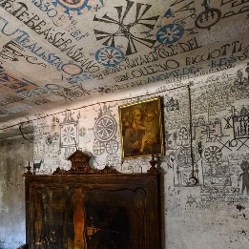

Agata and Federica | Meet Agata and Federica, the facilitators working with UTI Carnia (now Comunità di MONTAGNA della Carnia) to discover the hidden gems of Ovaro, Paularo and Prato Carnico. In over two months of interviews and meetings with locals, they have collected a lot of material and thanks to their passion and to the participation and enthusiasm of many people we have now plenty of interesting stories to share.  In this video Agata and Federica tell us about their experience in meeting people and conducting interviews and share with what they have enjoyed the most during the whole process.
VIDEO

Paularo: Scarpez | Meet Dina and Chiara, a mother and a daughter living in Paularo who are bringing forward and reinterpreting the Carnic art of “Scarpez”, traditional shoes made of cloth and offcut fabric. Dina has learned the craft from her mother, and then passed it on to her own daughter who has been herself studying fashion and design.  Chiara has thought of adding new designs and fabrics to the Scarpets traditional style, creating a fashionable item that more and more people are putting their eyes on. Their creations are create custom-made and we can bet that, now that we have aroused your curiosity, you too will want to check out their work as well as all the other gems Paularo has to offer.  Scarpez di Dina e Chiara FB: https://www.facebook.com/Scarpez-di-Dina-Chiara-142341802534970/?ref=page_internal
