EXCOVER TRANSNATIONAL MEETING | 22 – 23 – 24 MARCH 2022
Venue: Rijeka (CROATIA)

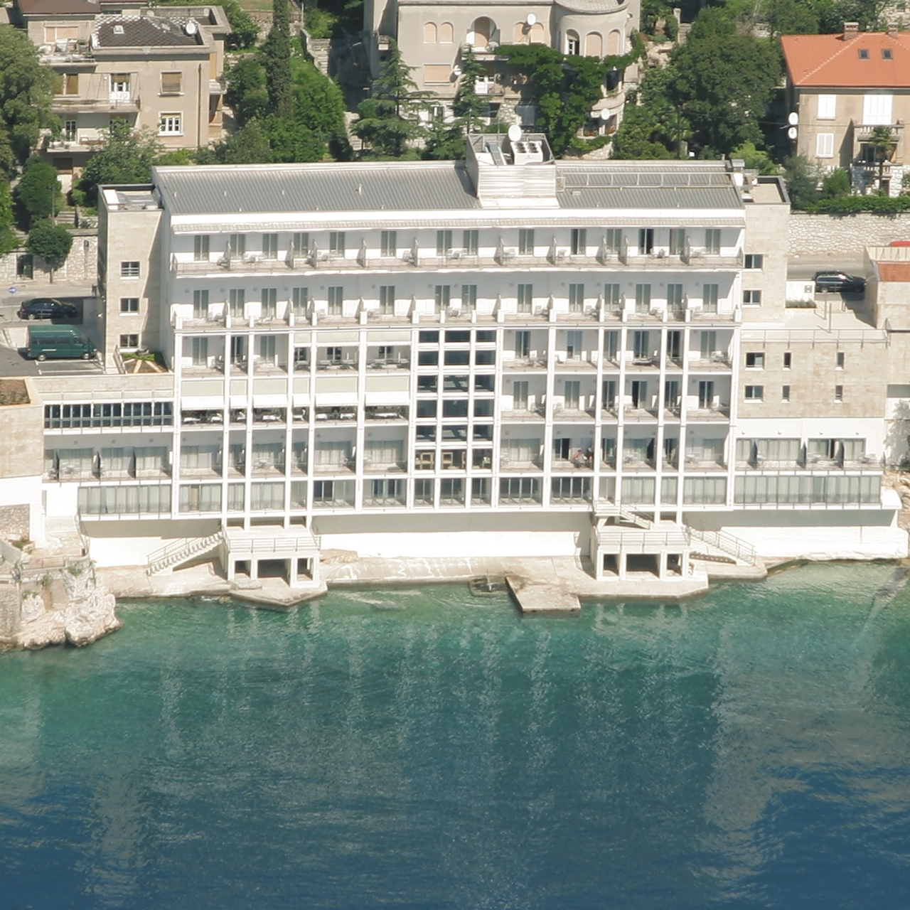

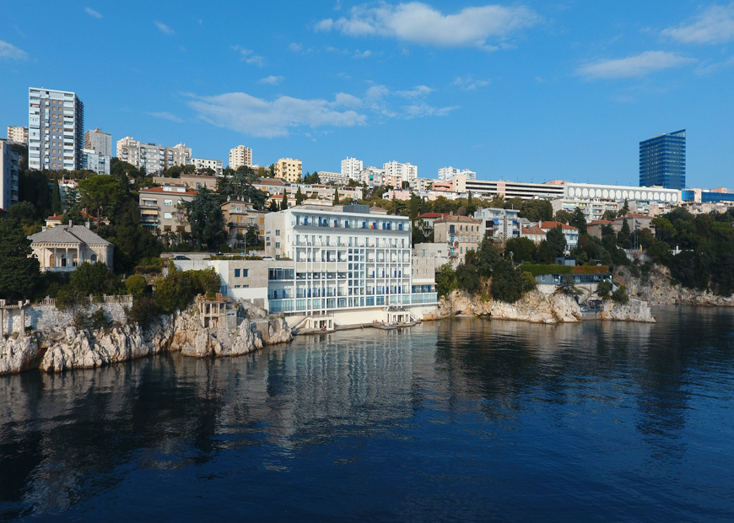 | 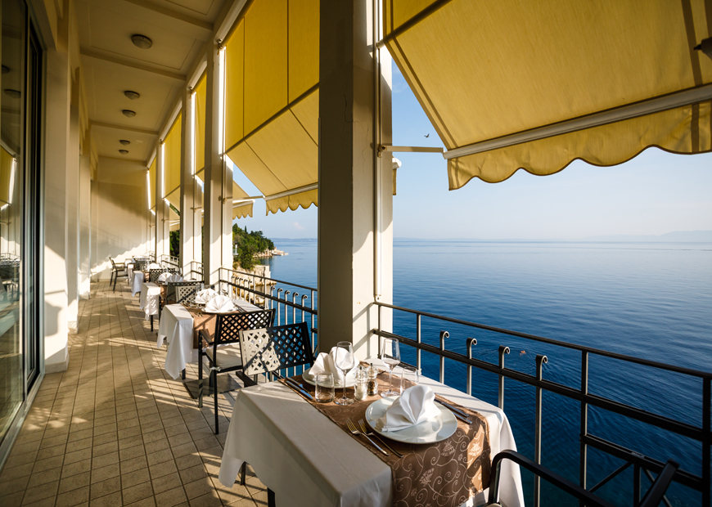
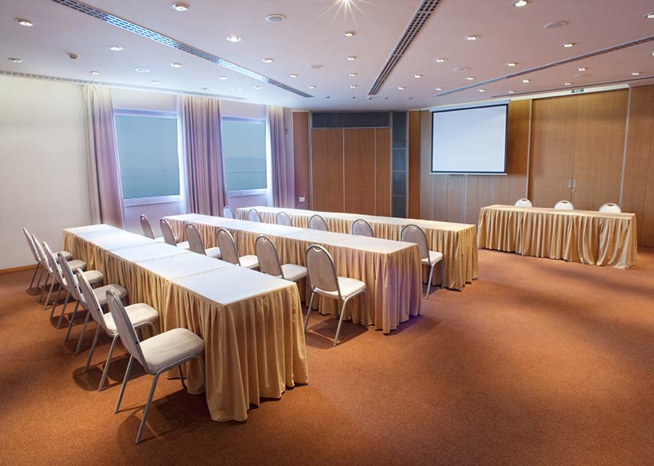 | 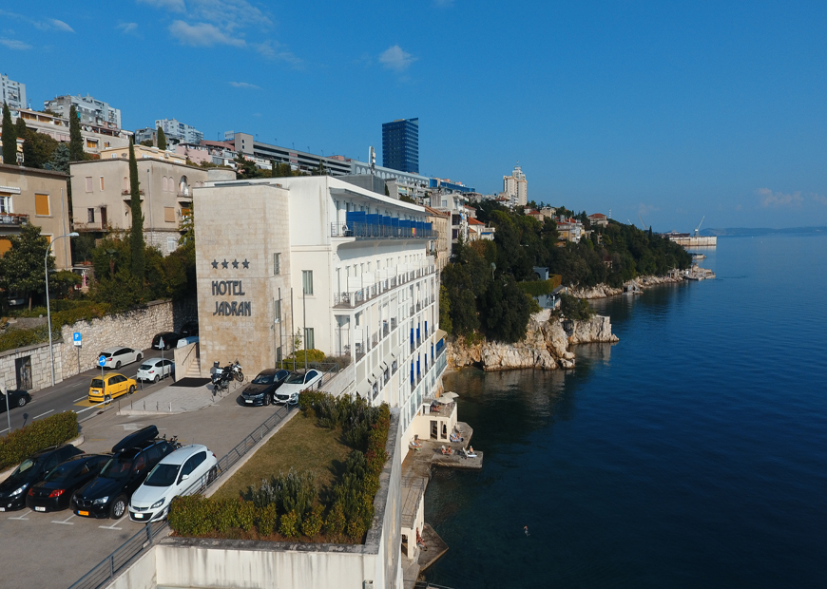

22 MARCH 2022 | TUESDAY | RIJEKA
LOCATION: Hotel Jadran, Šetalište XIII divizije 46, 51000 Rijeka
TIME |  | ACTIVITY
14:30 |  | Arrival of participants and welcome - Registration and signature of participants
14.45 WP4 Presentation of the results (University of Udine)
15.15 |  | WP5 Presentation of activities (Delta 2000)
16.00 Coffee break
16.30 |  | Action plan to finalise deliverables and activities within June 2022  Discussion on monitoring tools on deliverables produced so far
17.30 Closure of the activities
18.00 |  | Dinner at the Restaurant “Jadran” (paid by PGZ)
20.00 Overnight in Rijeka (accommodation at participants own expenses)
23 MARCH 2022 | WEDNESDAY | RIJEKA
LOCATION: Hotel Jadran, Šetalište XIII divizije 46, 51000 Rijeka
9.00 |  | Arrival of participants and welcome - Registration and signature of participants
9.15 WP Management (Spending, Reporting, Next steps) (LIRA)
9.45 |  | WP Communication (state of art) (JURRA)
10.15 |  | Steering Committee (approval of Action plan, next steps etc.)
10.45 |  | Lunch at the Restaurant “Jadran” (paid by PGZ)
11:45 |  | Departure for study visit
11.00 – 17.00 The Study Visit includes sightseeing of Municipality of Čavle and Frankopan Castle Grad Grobnik
17.00 |  | Come back to the Hotel
17.30 Free time
20:00 |  | Overnight in Rijeka (accommodation at participants own expenses)
24 MARCH 2022 | THURSDAY | RIJEKA
LOCATION: Hotel Jadran, Šetalište XIII divizije 46, 51000 Rijeka

09:30 Arrival of Participants | Registration and signature of participants
9.45 – 12.00 |  | Round table on next project activities for the finalization of the project
12.30 End of Meeting and services - Departure of participants
N.B. draft version: the contents & time schedule might be changed during the days of the meeting due to logistical reasons.

Information on:

HOTEL:
HOTEL JADRAN
Šetalište XIII divizije 46, 51000 Rijeka
(T) +385 51 216 600
(F) +385 51 216 458
jadran@jadran-hoteli.hr
https://www.jadran-hoteli.hr/jadran-en
https://visitrijeka.hr/en/odmori-planiraj-i-istrazi/smjestaj/lista-objekata/11087/

DIRECTIONS:
Arrival in Rijeka:
https://visitrijeka.hr/en/odmori-planiraj-i-istrazi/transport/arrival-in-rijeka/
Getting Around Rijeka:
https://visitrijeka.hr/en/odmori-planiraj-i-istrazi/transport/getting-around-rijeka/
City map:
https://odis.visitrijeka.hr/wp-content/uploads/2020/09/Plan-grada.pdf

COVID 19 - HEALTH EMERGENCY USEFUL INFORMATION:
https://mup.gov.hr/uzg-covid/english/286212
https://croatia.hr/en-GB/coronavirus-2019-ncov-q-and-a
https://www.koronavirus.hr/en

