EXCOVER TRANSNATIONAL MEETING | 22 AND 23 SEPTEMBER 2021
Venue: Alfonsine (Ravenna) | Ostellato (Ferrara)
22 SEPTEMBER 2021 | WEDNESDAY | ALFONSINE AND OSTELLATO
TIME | LOCATION | ACTIVITY
09:30 | Alfonsine – Casa Vincenzo Monti, Via Passetto, 2 | Arrival of participants in Alfonsine and coffee break
Arrival of Participants at Casa Vincenzo Monti | Coffee Break
10:00 | Alfonsine – Casa Vincenzo Monti | Bus Transfer for Study Visit (paid by DELTA 2000)
Bus departure for Alfonsine Study Visit *** be aware of COVID Measures
10:00 - 13.00 | Alfonsine | Study Visit of Alfonsine (paid by DELTA 2000)
The Study Visit includes Alfonsine main square, Museo della Battaglia del Senio, old Alfonsine and Casa dell’Agnese *** be aware of COVID Measures
13:00 - 14:00 | Alfonsine – Le Tradizioni di Nick, Corso G. Garibaldi, 67 | Light Lunch (Paid by Delta 2000)
Light Lunch with Local Products Tasting in Alfonsine | Restaurant: Le Tradizioni di Nick
14:00-15:00 | Alfonsine – Casa Vincenzo Monti, Via Passetto, 2 | Visit of Casa Monti Museum
Guided tour of Casa Vincenzo Monti, the birth house of the poet, playwright, translator and the greatest interpreter of Italian neoclassicism.
15:00 | Alfonsine – Ostellato | Individual Transfer
Transfer by own car from Alfonsine to Ostellato (Directions). Meeting point at the Vallette Natural Reserve.
15:30 | Ostellato – Vallette Natural Reserve, Via Argine Mezzano, 1 | Arrival of participants in Ostellato
15:30-17:30 | Ostellato – Vallette Natural Reserve | Study Visit Le Vallette (Paid by Delta 2000)
Guided Tour of The Vallette Natural Reserve with environmental guide
17:30 | Ostellato | Individual Transfer
Transfer to chosen hotel by own car
17:30-20:00 | Ostellato | Free Time
Free time to rest or to visit other attractions in Ostellato as Pieve di San Vito.
20:00 | Ostellato – Villa Belfiore, Via Pioppa, 27 | Dinner (Paid by Delta 2000)
Dinner in Ostellato at Villa Belfiore Restaurant
Overnight in Ostellato (accommodation at participants own expenses)
23 SEPTEMBER 2021 | THURSDAY | OSTELLATO
TIME | LOCATION | ACTIVITY
09:00-09:30 | Ostellato – Villa Belfiore, Via Pioppa, 27 | Arrival of participants
Arrival of Participants | Registration and signature of participants
09:30 - 12:00 | Ostellato – Villa Belfiore | Excover Meeting
09.30 - 10.15 WP4 Presentation of the results (University of Udine)
10.15 - 11.00 WP5 Presentation of next steps (Delta 2000)
11:00 - 11:15 | Ostellato – Villa Belfiore | Coffee Break
11.15 - 11.30 WP Management (Spending, Reporting, Next steps)
11.30 - 11.45 WP Communication (state of art)
11.45 - 12.00 Steering Committee
13:00 - 14:00 | Ostellato – Villa Belfiore | Light Lunch (Paid by Delta 2000)
Light Lunch break
14:00
End of Meeting and services
N.B. draft version: the contents & time schedule might be changed during the days of
the meeting due to logistical reasons.

Hotel in Ostellato

HOTEL MAP OSTELLATO: click here for directions

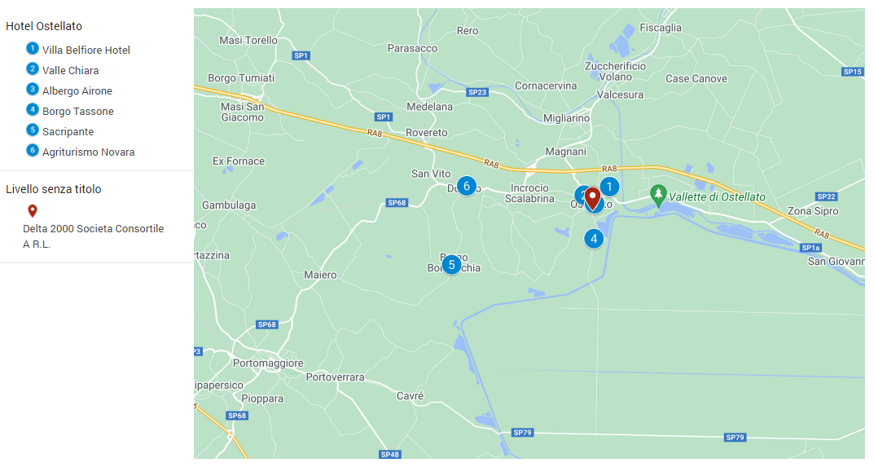

2
1
6
3
NAME | ADRESS | CONTACT PERSON | EMAIL | PHONE | WWW | PRICE
Villa Belfiore **** | Via Pioppa, 27, 44020 Ostellato FE | Fiorenza/Daniela | info@villabelfiore.com | 0039 533 681164 | https://www.villabelfiore.com/ | Double single use € 75 BB  Double € 90 BB
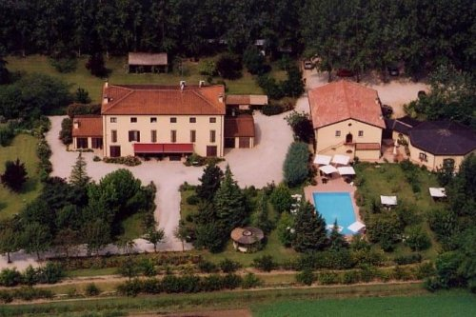
Villa Belfiore is located near Ostellato’s valleys, an oasis of peace just a few kilometres far from Ferrara, 20 minutes far from Comacchio, a charming town of Po Delta Park. Villa Belfiore is in harmony with the environment where fruit trees overlook the pool. You can collect and taste fruits and even appreciate the organic products of our farm. Your days will start with the right energy, breathing the air of the countryside and the breakfast fragrances. In summer you can relax yourself under the pergola. Depending on the season, you can also taste the most authentic homemade jams, for instance pumpkin jam made with a typical vegetable.
Valle Chiara | Via XX Settembre, 1870, 44020 Ostellato FE | Maria Cristina Chierici | info@valle-chiara.it | 0039 347 4216613 | http://www.valle-chiara.it/ | Apartment for 1 or 2 people € 72 ONLY BED
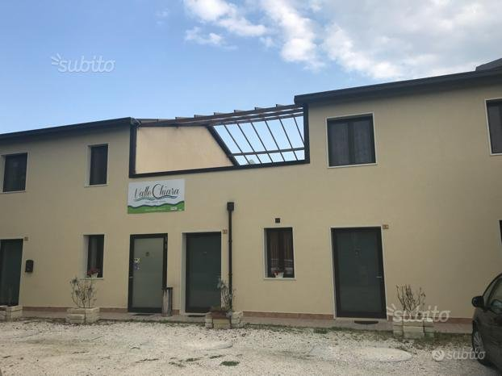
This name Valle Chiara carries on the traditions of the Chierici family, who since the 1950s has always operated in the hospitality sector, offering to its customers a service based on courtesy, familiarity and simplicity. Valle Chiara has 5 apartments: 3 on the lower floor and 2 on the upper floor. All apartments have double or single beds, sofas and / or relaxing armchairs, a comfortable dining area, dressing room and private bathroom.
Albergo Airone ** | Via Giuseppe Garibaldi, 25, 44020 Ostellato FE | Sandra Brunaldi | info@albergoairone.it | 0039 389 344 0944 | https://www.albergoairone.it/ | Double single use € 50 BB  Double € 75 BB
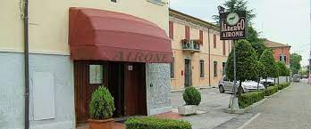
Albergo Airone offers a quiet setting in Ostellato, close to Delta del Po nature reserve and a 30-minute drive from the beaches along the Adriatic coast. On-site parking is free. All rooms at Airone have a TV and private bathroom. This family-run hotel also features a private garden where you can enjoy a drink from the bar.
4
Borgo Tassone | Str. del Mezzano, 241, 44020 Ostellato FE | Andrea | info@iltassone.it | 0039 338 9994924 | http://www.iltassone.it/ | Double single use € 45 BB  Double € 80 BB
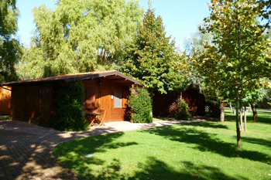
The Borgo Tassone opened in 1990. A unique location, where you can a spend a vacation in in relax, amongst nature's landscape. It is composed by several independent wood houses, where it is possible to enjoy your holidays, as well as a weekend away from the city, in the peacefulness that only these places can offer you. Moreover, you will be able to taste typical country dishes, perhaps while standing next to a fireplace, or simply while enjoying the magnificent view of the cultivated fields from the restaurant's windows.
5
Sacripante | Str. Bordocchia, 160, 44020 Ostellato FE | Stefania | info@ilsacripante.it | 0039 334 3655964 | https://ilsacripante.it/ | Double single use € 50 BB  Double € 80 BB
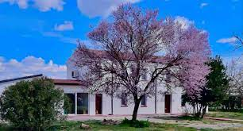
Located in the countryside, it is surrounded by 4000 square meters of park with a beautiful swimming pool. The park is equipped for outdoor dining during the spring and summer season. Large private parking. All rooms have with free Wi-Fi, individual air conditioning, safe, mini-bar with a rich assortment and sweet and savory snacks, television and private bathroom. Breakfast is included with a rich buffet of quality products, including gluten-free (with gluten-free certification). Guests can access to the library, with books of all kinds for adults and also for our younger guests and with a wide range of board games.
Agriturismo Novara  6 | Via Ferrara, 61, 44020 Ostellato FE | Giovanni | info@agriturismonovara.it | 0039 338 4713286 | http://www.agriturismonovara.it/home.asp | Double single use € 40 BB  Double € 60 BB
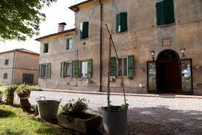
The working farm owes its name to the birthplace of Bartolino, the architect of the 14th century old Estense Castle in Ferrara and first owner of the estate. The Arzenton family bought the property in 1926. The present farmhouse dates back to the 19yh century. A reception hall, 2 dining rooms and a lounge welcome the guests. It has 7 spacious and bright guestrooms, 4 of which with private facilities TV and AC and 3 rooms with shared shower and Wc.

DIRECTIONS

How to reach Casa Vincenzo Monti – via Passetto 2 – Alfonsine (Ra)

From Firenze to Alfonsine:
Drive along Motorway A1 direction Bologna; once arrived in Bologna take Motorway A14 direction Ancona and take exit Diramazione Ravenna. At the roundabout take the 1 st exit, Strada Provinciale 8 towards Bagnacavallo up to Alfonsine.
Google Maps: From Hotel Mediterraneo to Alfonsine Casa Vincenzo Monti
From Croatian border to Alfonsine:
Take Motorway A4/E70 in Fogliano Redipuglia from Strada Statale 14 and Strada Statale 677. Follow Motorway A4/E70 and take exit A13 towards Bologna/Padova Zona industrial. Follow Motorway A13 and take exit Ferrara Sud. Follow RA8 and take SS16 towards Portomaggiore/Argenta/Alfonsine/Ravenna up to Alfonsine.
Google Maps: From Croatian border to Alfonsine Casa Vincenzo Monti
From Rimini to Alfonsine:
Take Strada Statale 16 towards Ravenna, Bellaria, Igea Marina. Pass Cesenatico, Cervia and Ravenna and continue on Strada Statale 16 up to Alfonsine.
Google Maps: From Rimini to Alfonsine Casa Vincenzo Monti

COVID 19 - HEALTH EMERGENCY USEFUL INFORMATION

ENTERING ITALY: check here for updated infos:
- http://www.italia.it/en/useful-info/covid-19-updates-information-for-tourists.html
- https://infocovid.viaggiaresicuri.it/index_en.html

THE COVID-19 GREEN PASS: WHERE IS IT MANDATORY? Check here https://www.esteri.it/mae/en/ministero/normativaonline/decreto-iorestoacasa-domande-frequenti/focus-cittadini-italiani-in-rientro-dall-estero-e-cittadini-stranieri-in-italia.html
From 6 August, on the Italian national territory, you will need a Covid-19 digital certificate (Green Pass), or equivalent certificate recognized by the Italian authorities, to enter:
- the indoor areas of restaurants;
- theatres, cinemas, events and sports competitions;
- museums and other cultural venues;
- swimming pools, gyms, spas and wellness centres, theme and amusement parks, recreational and leisure centres, gaming halls and casinos;
- trade fairs, conferences and meetings.
From 1 September, you will need a Green Pass, or an equivalent certificate, to board:
- airplanes;
- interregional ships and ferries (except for the Straits of Messina ferry services);
- Intercity and High Speed trains;
- long-distance buses;
- charter buses.
A Green Pass, for the use in the national territory, is issued to all persons who have received at least one dose of vaccine or who have received a negative (molecular or antigen) swab test within the previous 48 hours or who have recovered from COVID-19 in the previous six months. Please note that a certificate certifying the first inoculation of a two-doses vaccine (second dose pending) is not enough to enter Italy from abroad.

BUS TRANSPORTATION
In order to organize a safe bus transfer in Alfonsine, it is mandatory to present a valid Green Pass Certificate and to specify if you are travelling with cohabiting people or relatives.

