SCIENTIFIC REPORT

WP4 – Activity 4.2–Fishing for litter catches: composition and quantities definition
DELIVERABLE 4.2.4
Partner in Charge: LP
Partners involved: LP, PP1, PP2, PP4
Status: Final
Distribution: Public
Date: 30/09/19

Summary

1. Fishing for litter catches: composition and quantities definition – the plastic fraction. 1
2. Characterization of Marine Litter from Fishing for Litter activities 2
2.1. Sampling site and Fishing for Litter areas involved in the study 2
2.2. Waste Items classification in Marine Litter 5
2.3. Plastic Polymer identification in the Marine Litter 11
2.4. Integrated cross comparison of Litter classification and polymer identification results 16
3. Degradation of bottles collected in Italian and Croatian areas 19
4. References 29

- Fishing for litter catches: composition and quantities definition – the plastic fraction.
Within the Work Package 4, Supporting the Implementation of Fishing for Litter Activities, and in detail in the Activity 4.2, the composition and the quantities of Marine Litter catches during the Fishing for Litter practice were monitored for marine areas involved in the IT-HR project ML-Repair. In the other Deliverables provided as outcome of project for this activity, especially for D4.2.1and D4.2.3, (FfL Database and Final report containing the results, respectively), Marine Litter is estimated as whole, considering total weight of collected litter (per fish vessel involved per each month of the ML-Repair project) and the weight of single materials, intended as gross classes, i.e., metal, paper ,wood, rubber, plastic, etc. In this context, the following work is focused on plastic fraction derived from Marine Litter. In order to explore the condition and potential use for a future recycle of this marine plastic waste, two studies were carried out. In the first, plastic samples, which were collected in fish port disposal site, were characterized to define, contextually, the composition as items category and the identification of plastic polymer in the materials. The results proposed provide a picture of the features and differences of plastics recovered by means of FfL in relationship with Adriatic area of catches, even though it is important to avoid considering the results obtained as a potential map of marine litter coverage on the seabed. In the last part, the topic of marine litter plastics degradation, was addressed. For this work, drink bottles from ML were selected as “item indicator” to assess the concurrent degradation processes of PET (body of bottles) and PE (caps and ring), two of the main plastic polymers in the daily uses and potentially constituting a large portion of ML plastic fraction.

- Characterization of Marine Litter from Fishing for Litter activities
  - Sampling site and Fishing for Litter areas involved in the study
In order to study the composition of the plastic ML fraction collected during FfL activities in the Adriatic Sea, two areas have been selected along the Italian and Croatian coasts, respectively. These monitoring areas were identified by the presence of a significant number of ships, already involved in the FfL practice, and of disposal sites equipped to collect the marine litter recovered by fishermen; the sampling was carried out using the support of other project partners (PP1 PP2 for Italian and PP4 for Croatian sites) also involved in the determination of the composition and quantity of ML caught by trawl fisheries. This last aspect, besides the evident logistic support, is important because it allowed contextualizing the characterization of the plastic fraction with other monitoring activities carried out in the project.

 | Disposal Site | Fishing Area | Depth (m) | Date  (ISO format) | Sampling campaign code
Chioggia (VE) | Chioggia  Fish market | Coastline in front of Po river Delta | 10-30 | 18/06/21 | IT/CH/06/18
Chioggia (VE) | Chioggia  Fish market | Offshore in front of Venetian coast | 20-35 | 18/12/19 | IT/CH/12/18
Hvar.  CFZ G4 | Tribunj, Rogoznica, Supetar (Brač) and Vira (Hvar) | Channel waters between Hvar and Brač | 80 | 19/01/24 | HR/G4/01/19
Tribunj.  CFZ C1 | Tribunj, Rogoznica, Supetar (Brač) and Vira (Hvar) | Open waters offshore Šibenikcoast | 150 | 19/02/12 | HR/C1/02/19
Rogoznica-Blitvenica. CFZ C4 | Tribunj, Rogoznica, Supetar (Brač) and Vira (Hvar) | Open water around the Vis island | 200 | 19/02/14 | HR/C4/02/19
Tribunj.  CFZ F2 | Tribunj, Rogoznica, Supetar (Brač) and Vira (Hvar) | Channel waters in front of Šibenikcoast | 150 | 19/02/19 | HR/F2/02/19
Table 1: Sampling site location, disposal area in fishing port, involved areas of FfL, sampling dates, bathymetry and sampling campaign code.
In Table 1 and Figure 1, the disposal sites where the sampling of items was performed, are reported, together with the location and a brief description of the fishing area subjected to the FfL activities. In the same table information related to the estimated bathymetric depth, sampling dates and the sampling campaign codes is reported. These named the samples and identify the results in this report and in database generated by the monitoring results. The generation of code was described in Deliverable 2.4.5, Marine Plastics Characterization Protocol; the first labels of the code represent the nation (IT for Italy and Croatia HR) and locations where the sampling occurred: for Italian samples, the code “CH was assigned, indicating the disposal site inside the Chioggia fish market, while for Croatian samples an identification code, related to marine area location of FfL implementation and used by Croatian Authorities to label the different national fishing area (CFZ, Croatian Adriatic Fishing Zone) was adopted The two numbers in the code indicate the sampling date (mm/yy).

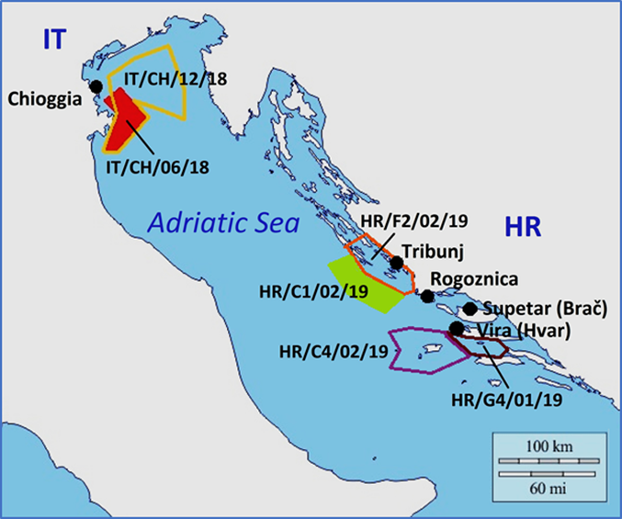
Figure 1: Adriatic Sea map with location of ML disposal sites in Italian and Croatian fishing ports and FfL implementation areas involved at sampling date.
In Figure 1, a map of Adriatic Sea with overall location of the waste sampling sites (marked as black point) and Fishing for Litter areas is reported, involved in such activities at the sampling date.
The sampling activities in Italy were carried out in the Chioggia (VE) fish market, which is the main fishery port in the Italian Northern Adriatic, at the disposal site located inside the port facility. This was equipped during previous projects related to Fishing for Litter, including the DeFishGear Project, and it constitutes a well consolidate outcome resulting by collaboration between Municipal Authorities and Italian Institute for Environmental Protection and Research, ISPRA (Istituto Superiore per la Protezione e la Ricerca Ambientale), Chioggia branch office, partner in the present project (PP1). The waste disposal site consists of a demountable container, removed and emptied weekly by the municipal waste disposal company. The access to the site is permitted only to the fishermen of vessels participating in the Fishing for Litter practice and the use of this container is strictly limited to the collection of Marine Litter. In order to individuate the vessels responsible to waste collection, the FfL bags are labeled or marked. This practice, together with information provided by fisherman responsible for the waste collection, allowed to locate fishing areas where marine litter was recovered with the aim of contextualizing the area of waste origin with the results of the estimation of the quantities and compositions for categories and materials, which represents the main goal of this study.
In Figure 1 and, in detail, in Figure 3 it is possible to observe that, in the first Italian monitoring campaign in June 2018, IT/CH/06/18, the FfL Area was close to the coastal area, covering an area located at south of Chioggia port and at the limit of the northern coast of Emilia-Romagna region, through the front of Po river Delta. During the second sampling campaign, IT/CH/12/18, the interested area for FfL extended over an area that included almost entirely the Italian part of the Gulf of Venice. The bathymetry in this section of the Adriatic Sea and, particularly, in areas interested in the FfL monitoring, ranged from 10 to 35 meters in depth. The main rivers that flow into the area are: Po, Adige, Brenta, Piave, Tagliamento and Livenza. The catchment area of these rivers covers a large part of northern Italy. Main harbors are Venice and Trieste, while Chioggia represents the main fish port for Italian northern Adriatic (with more than 200 fishing vessels).
The Croatian sampling campaigns were implemented by the project partner PP4, the Institute of Oceanography and Fishery (Institut Za Oceanografiju I Ribarstvo) of Split, and were performed during January to February 2019, Marine Litter was collected in four fishing port: Tribunj, (10 km North-East of Sibenik), Rogoznica (between Šibenik and Split), Supetar (on the Brač Island, in front of Split) and Vira (on the Hvar Island, southern to the Split coast). The areas covered by the FfL practice have been defined by the Croatian fisheries regulations allowing activities in certain fishing areas at certain times. Therefore, this permitted to identify with certainty the areas affected by the recovery of marine litter. In Table 1, these were indicated as CFZ (Croatian Fishing Zone). The CFZ G4, the first involved in the monitoring in January 2019, is constituted by the channel between the islands of Hvar and Korčula at east of Split (sample HR/G4/01/19). In February 2019, collection of the samples was carried out respectively in CFZ C1, in open sea water at south-east of Sibenik, outside the line constituted by Kornat and Žirje islands, in CFZ C4, in the open sea water around the Vis island and delimited at east by Hvar and Korčula islands and at west by Svetac island, and in CFZ. F2, in the channel coastal water located at east of the Šibenik shoreline and inside the line constituted by the Kornat and Žirje islands. The bathymetry ranged from 80 m (G4, Korčula channel) to 200 m (C4, Vis island area) in depth. The main rivers of the area are Krka, Cetina and Neretva. Main towns of this coastal area are Split and Sibenik.
  - Waste Items classification in Marine Litter
All in collected ML sample items were classified according to the definitions proposed the Guidance on Monitoring of Marine Litter in European Sea [Hanke et al. 2013] within the Marine Strategy Framework Directive Technical Subgroup on Marine Litter (MSFD-TSG). The proposed items list is detailed and allows to depict the level of marine pollution by anthropogenic litter and to identify the potential source for this kind of sea deterioration. While the list proposed by MSFD-TS allowed drawing a very precise picture of the situation, the excessive detail, however, makes it very difficult to compare classification results with other acquired information. Therefore, in order to develop an easier comparison with data obtained from the identification of materials, a more synthetic classification system has been adopted in parallel. The more synthetic classification system chosen proposed in the United Nations Environment Program/Intergovernmental Oceanographic Commission (UNEP/IOC) Guidelines on Survey and Monitoring of Marine Litter Regional Seas Reports and Studies [Cheshire et al., 2009)] was applied.
Therefore, in MSFD-TSG the comparation from its and UNEP/IOC codes for marine litter items is reported. In Table 2 the codes cross comparison of the two list, limited to the items find in the project sampling campaigns, with related description and definition are shown.
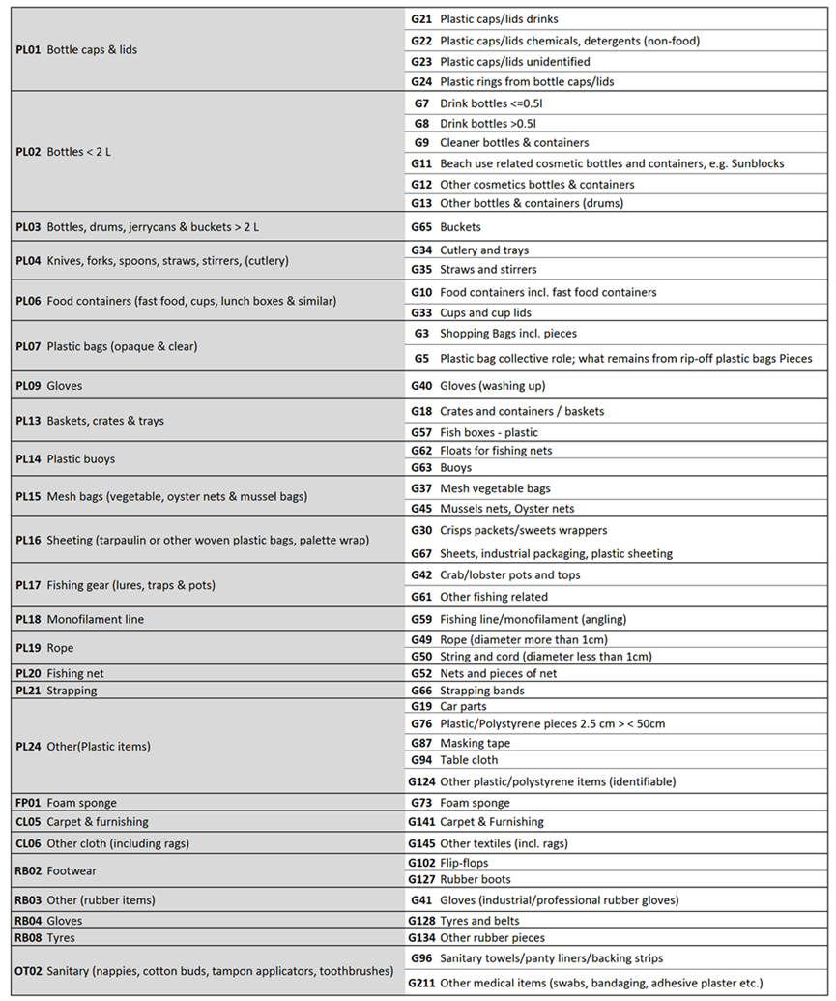
Table 2: Comparative list of codes, names and definitions of collected ML items according to of UNEP/IOC (grey) and the MSFD-TSG Guidelines for Marine Litter Monitoring (white) classifications; the list is limited only to categories of items collected during this study.
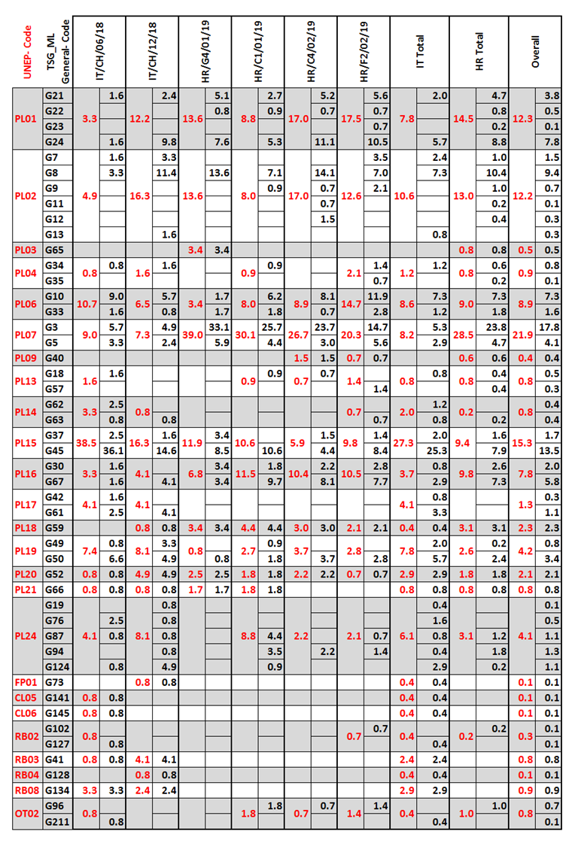
Table 3: Category Compositions of ML samples according to UNEP/IOC and MSFD-TSG Classifications for Marine Litter. Data are reported as percentage (%) for all Italian and Croatian campaigns sampling campaigns.
In Table 3, the results of marine litter items classification for each of the six sampling campaigns and aggregated for the Italian and Croatian campaigns and overall project, are reported. All data represent the percentage of numerical abundance.

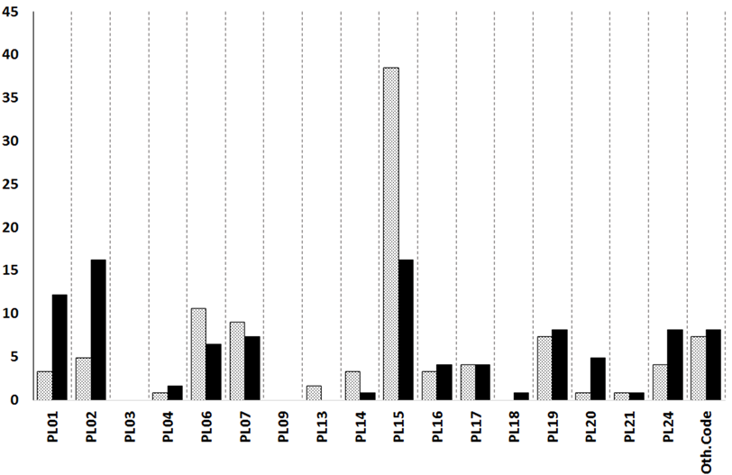
Figure 2: Litter category distribution of ML samples from Italian sampling campaigns IT/CH/06/18 (dotted gray) and IT/CH/12/18 (solid black) according to UNEP/IOC classification [Cheshire et al., 2009].
In Figure 2 the results from the samplings in the Italian disposal site are shown. It is possible to observe that in the first campaign, IT/CH/06/18, most abundant items belong to PL15, mesh bags (38.5% of total). Using MSFD-TSG classification in Table 3, it is evident the huge contribution of code G45 (36%), corresponding to mussel nets. In Figure 3, reporting detailed maps relative to northern Adriatic FfL areas involved, it is possible to note that in the first campaign fishing zone limited to an area close to the coast and, potentially, to mussel farms. In the second campaign, IT/CH/12/18, the contribution of mussel net was noticeably reduced, even if remaining one of the largest, while there is a growing contribution of PL01 and PL02, representing bottles and caps. In Figure 3, it is shown that in IT/CH/12/18 the extent of the seafloor subject to trawler activities covered a large part of northern Adriatic, mediating, probably, the contribution from different sources of waste.
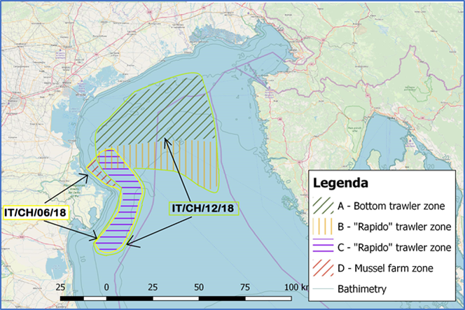
Figure 3: Maps of Northern Adriatic with FfL implementation areas involved at sampling dates. Different areas are related to fishery gear used (see Legenda; maps and information by PP1).

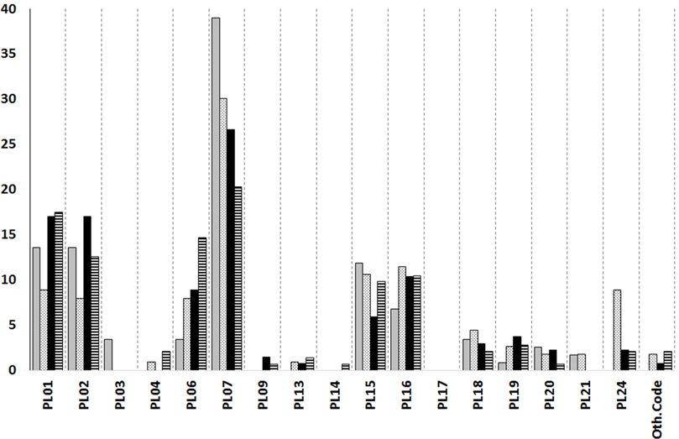
Figure 4: Marine Litter category distribution of ML samples from Croatian sampling campaigns, respectively HR/G4/01/19 (solid gray), HR/C1/02/19 (dotted gray), HR/C4/02/19 (solid black) and HR/F2/02/19 (black and white strips) according to UNEP/IOC classification [Cheshire et al., 2009].
In the samples from the Dalmatian coast, the histogram in Figure 4 highlighted a substantial contribution of items belonging to PL07, representing plastic bags, especially for HR/G4/01/19 sample taken in the area between Hvar and Korčula, with a percentage 39%; the percentage of bags is halved (20%) in the sample taken in the area between the coast of Šibenik and the islands in front of this town, HR/F2/02/19 (see also Figure 5 with location details for CFZ corresponding to FfL areas contributing to the samples). For this last sample, instead, it is interesting to highlight a 15% of PL06, corresponding to food containers. Bottles and relative caps and ring constituted an important part in HR/G4/01/19, HR/C4/02/19 and HR/F2/02/19. For the sample from campaign HR/C1/02/19, an open sea area, shown in general a more heterogeneous composition, also for the contribution of miscellaneous class, PL24. The PL15 items, mesh bags, largely compounded by mussel net, amount approx. to 10% in HR/G4/01/19, HR/C1/02/19, and HR/F2/02/19.

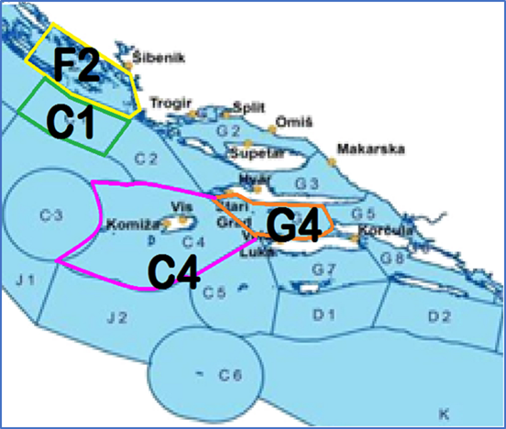
Figure 5: Map of Croatian Adriatic Fishing Zones in the coastal area of Šibenik and Split with highlighted areas involved in the FfL implementation.
The comparison of overall results from Italian and from Croatian samples, shown in the figure 6, pointed out a substantial difference in relationship to the item categoriesfor plastic litter coming from the two area. The first evidenced aspect was the large contribution assemblage by a remarkable huge in PL15 for Italian areas, due the large presence of aquacolture farm along coastline from Veneto to Emilia-Romagna, whereas PL07 dominated Croatian marine waste assemblage. The categories PL01 and PL02, bottles and related, are an important part of marine litter, albeit mostly for the Croatian samples. Other relevant difference in Croatian samples compared to Italian, was the presence of PL16, principally sheets for packaging (G67), almost 10%. In general, apart from the large quantity of mussel nets, the Italian samples are characterized by a greater heterogeneity, with objects of different nature, as evidenced by the code PL24, indicating miscellaneous objects and other items (Other Code), widely constituted by rubber workwears (Gloves, Boots etc.).

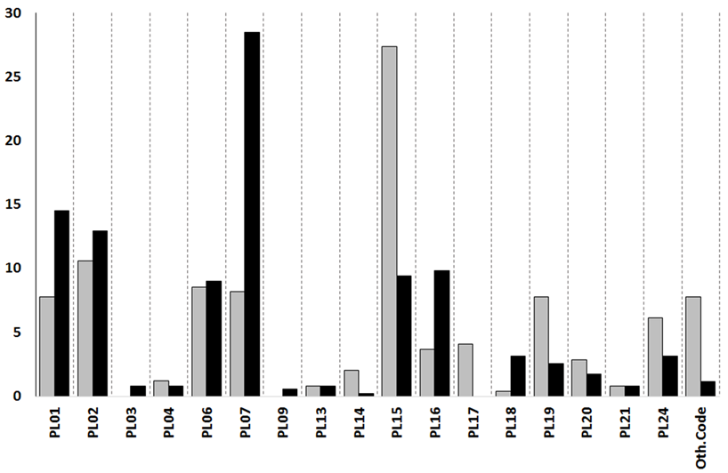
Figure 6: Litter category composition of the overall ML samples from Italian (solid gray) and Croatian (solid black) samples according to UNEP classification [Cheshire et al., 2009].

  - Plastic Polymer identification in the Marine Litter
During the project plastic items were characterized in order to identify their polymeric composition, by means of vibrational spectroscopy:
- Near Infrared Spectroscopy (NIR, all sampling campaigns)
- Fourier-Transform Infrared Spectroscopy in Attenuated Total Reflection mode (FTIR-ATR, applied to samples IT/CH/06/18, IT/CH/12/18, HR/G4/01/19 and HR/C1/02/19)
- Raman Spectroscopy coupled to Optical Microscopy (μ-Raman, applied to sample IT/CH/06/18)
Detail on the techniques and methods are presented in the D4.2.5 Marine Plastics Characterization Protocol. Data used in this report resulted by an expert comparison process of the analytical outputs from different techniques, when more methods were applied. Results from different spectroscopic techniques applied showed, respectively, a large consistency. Data and relative data are referred to numerical abundance not in weight.
Some objects could exhibit multiple characterizations in the case of multilayer or composite materials. Such items are specifically indicated in the attached database listing.
In the following Table 4 are reported explanation for acronyms relative to polymeric materials.
Acronym | Name | Notes
PE | Polyethylene
PP | Polypropylene
coPE-PP | (Polyethylene Polypropylene) | Copolymer or mixture (not discriminable)
PET | Polyethylene terephthalate | Polyesters
PS | Polystyrene
PVC | Polyvinylchloride
PA | Polyamides | Nylon 6,6 and Nylon 6,6
SAN | Styrene-acrylonitrile
PC | Polycarbonates
PMMA | Poly (methyl methacrylate) | Plexiglass®
Polyimide | - | techno polymer class
PDMSO | Polydimethylsiloxane | “silicone” elastomer
Cellulose | -
Methylcell. | Methylcellulose
N.I. | Not Identified
Table 4: Explanation of applied acronyms for plastic polymers. In notes supporting information is reported.
In Table 5, results of identification are shown, on the left as absolute output produced (A), whereas on the right relative data for each sampling campaigns were reported, for national (aggregated) and overall of the entire project. In the table all polymers encountered, comprehensive of uncommon polymers, cellulosic material or ingredients in adhesive materials (PDMSO), were listed. In the following histograms, Figures 7-8-9, attention has been restricted to the main plastic materials found in the collected marine litter, adding up the contribution of less significant polymers, cumulatively reported as other polymers (Oth.Pol.).

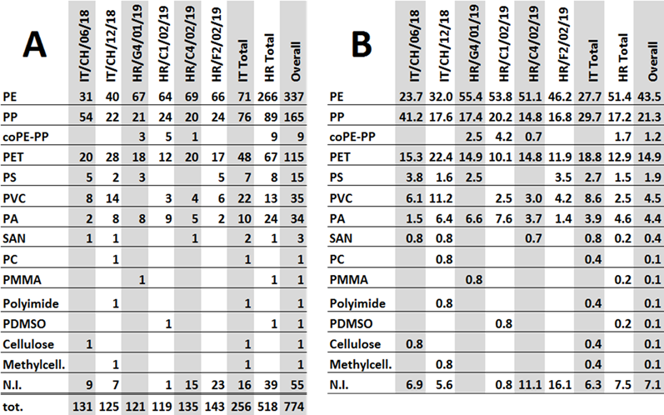
Table 5: Polymer identification results. On the left (A) numbers of polymer identifications for each sampling session and for overall Italian, Croatian and entire project samples are shown. On the right (B) the results are reported as relative percentage for each sample and aggregation.
In Figure 7, the histogram depicts the composition of Italian samples as polymer percentage. In IT/CH/06/18 sampling session, the preponderant presence of PP, up to 41%, characterized the materials recovered. Other important contributions for this sample were given also by PE (24%) and PET (15%). In complex, the sum of the relative abundance values of these main three plastic materials (PE, PP and PET) amounted to 80%. In the second sampling campaign, IT/CH/12/18, the portion of PP was reduced to 18% while PE and PET increased, to 32% and 22%, respectively. The amount of the relative abundance values of the main three plastic materials (PE, PP and PET) reached 72% of total. Moreover, the quantity of PVC (11%) and PA (6.4 %) resulted noticeable.

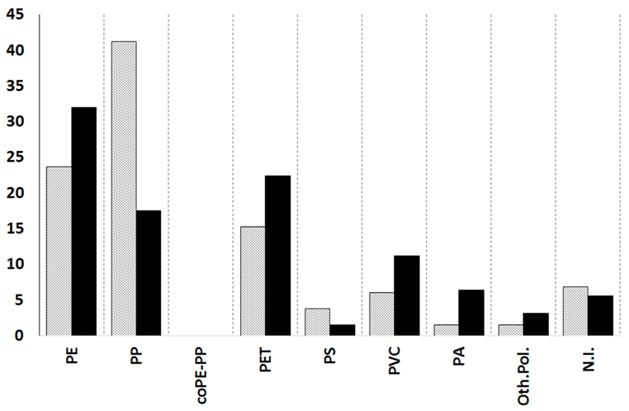
Figure 7: Polymeric distribution of the ML plastic items collected during Italian sampling campaigns IT/CH/06/18 (dotted gray) and IT/CH/12/18 (solid black).
In the histogram in Figure 8 the polymeric distribution of samples from Croatia is shown. For the composition of all samples, PE presented a relevant percentage, ranging from 46% in HR/F2/02/19 to 55% in HR/G4/01/19, whereas PP and PET contributed to a markedly lower portion, even though important with range between 10-15% for the former and between 15-20% for latter, respectively The relative abundance values of the main three plastic materials, PE, PP (considering also PE-PP copolymer) and PET reached 90% in HR/G4/01/19, 88% in HR/C1/02/19, 82 in HR/C4/02/19 and 75%HR/F2/02/19, respectively. PA provided also an interesting contribution in HR/G4/01/19 (6.6%) and in HR/C1/02/19 (7.6%), respectively.
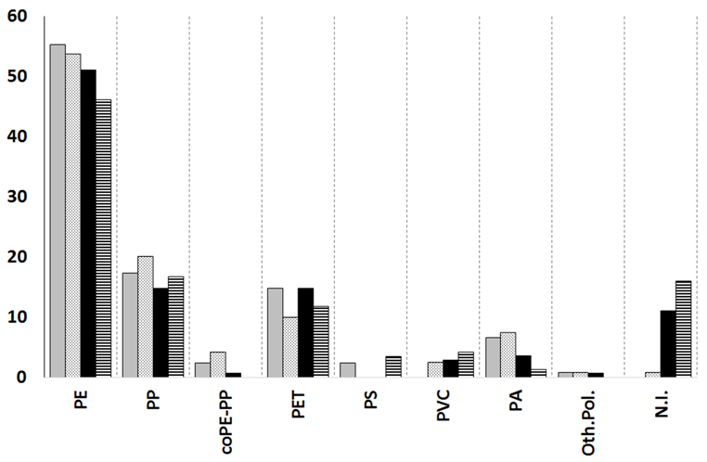
Figure 8: Polymer distribution of ML plastic items collected during Croatian sampling campaigns HR/G4/01/19 (solid gray), HR/C1/02/19 (dotted gray), HR/C4/02/19 (solid black) and HR/F2/02/19 (black and white strips).
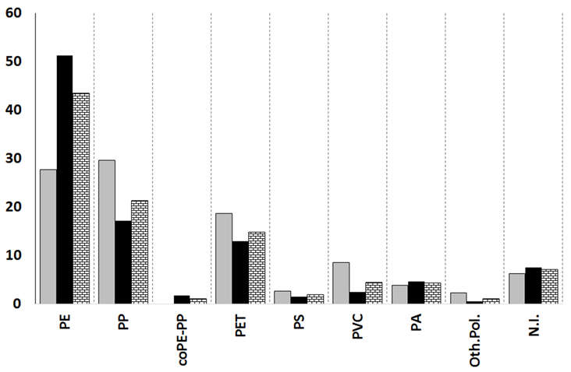
Figure 9: Polymer distribution of all plastic ML items collected during Italian (solid gray) and Croatian (solid black) sampling campaigns, and within entire project (wall shape).

In the last histogram of this section (Figure 9), an overall comparison between the composition in Italian and Croatian samples allowed to highlight relevant difference among the areas investigated in Italy and in Croatia, respectively. Croatian overall data were characterized by a higher contribution in PE (51%) with respect to PP (17%) and PET (13%), whereas the results for Italy exhibited an almost even distributed presence of PE (28%), PP (30%) and PET (19%). The presence of PVC reached approx. 8.6% in Italian overall results.
  - Integrated cross comparison of Litter classification and polymer identification results
In order to obtain a better understanding of the relationship between the types of items present in marine waste and the contribution made to the presence of certain polymeric materials, a cross-comparison between the results obtained by means of the category classification and the polymer determinations was also conducted.
The output of cross-comparison is shown in Table 6 for Italian and in Table 7 for Croatian area, respectively.
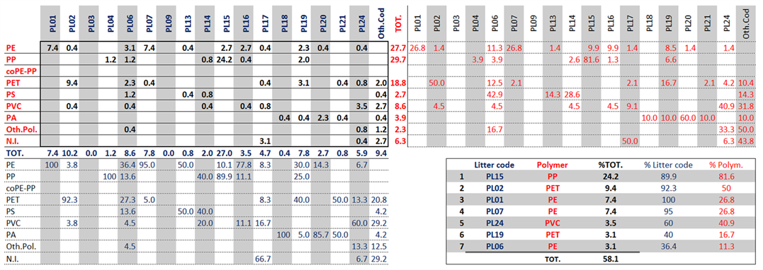
Table 6: Cumulative data for the Italian area overall results according to litter category classification (Litter code) and polymer identification data.
The tables are composed by 4 sub-tables; in the first sub-table, at the top right in black the composition in percentage for each specific category of litter item having a defined polymeric composition are reported. The table at the top left and bottom right shows some detailed information. The sub-table at the top left shows in red the relative contributions of each marine litter category to a specific polymer, while the sub-table at the bottom right shows in blue the relative contributions of each polymer to a specific marine litter category. Finally, in the lower right sub-table, seven categories of waste composed of a certain polymer with the highest percentages are reported. These seven data represent a cumulative percentage of more than 50 % and can therefore provide an adequate representation of the total data set for a given area.
The result of cross-comparison indicated that most numerous specific items in marine litter from Italian area (table 6) were PL15/PP (24%), i.e. mesh bags (specifically mussel net) in polypropylene, whereas for Croatia (table 7) were PL07/PE (26%), polyethylene bags.
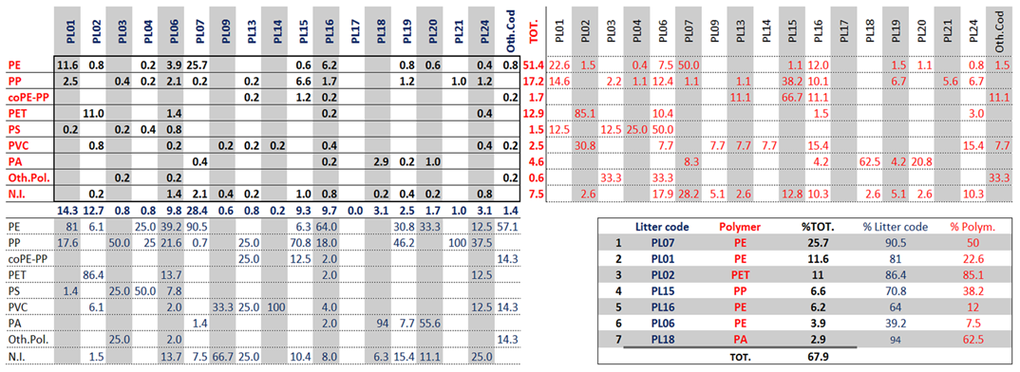
Table 7: Integration between litter category classification (Litter code) and polymer identification data for the Croatian area overall results.
Output of seven most numerous from Italian and Croatian data set was confronted in figure 10. In this case there are five combination, which are shared by two “most numerous” data set, PL01/PE (caps), PL02/PET (bottles), PL06/PE (food container), PL07/PE (bags) and PL15/PP (mussel net) and other four “most numerous” different. In the histogram (fig. 10) were used the data of the all nine specific items to allow a wider confrontation from Italian and Croatian results.
Moreover, a graphical approach to point out difference from the two data set in the figure 11, transforming the percentages into scores, as shown in Table 8, was generated. The two specific items in the sets with the highest percentages (PL15/PP for IT and PL07/PE for HR) were given a score of 10, while the others were given a proportional score, as shown in Table 8 and Figure 11. Scores are displayed in a plot with nine axes in order to visualize the differences in the structure of the two data distributions.
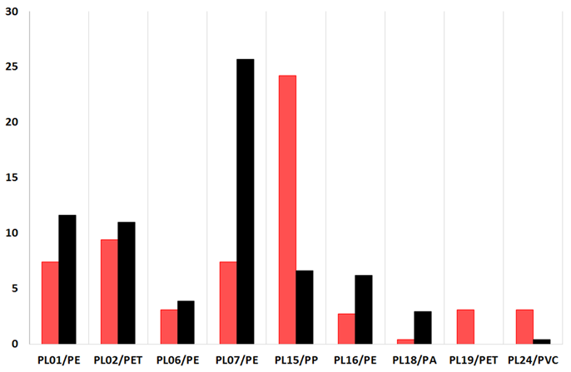
Figure 10: Seven most abundant Marine Litter specific items in Italian (red) and Croatian total dataset.

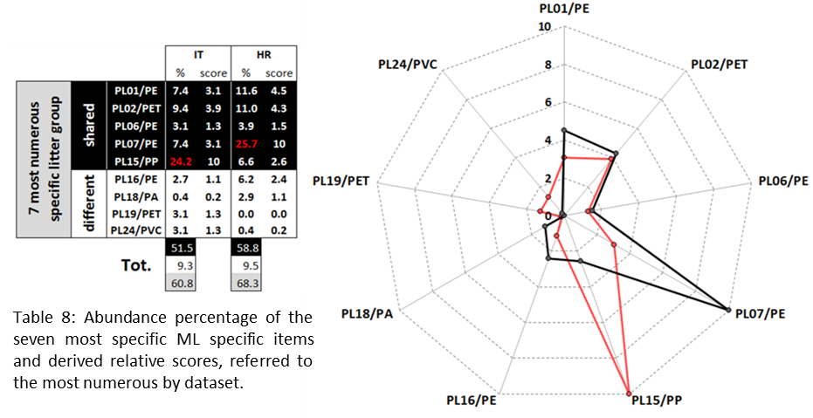
Figure 11: Graphical approach for comparison between Italian (red line) and Croatian (black line) total dataset based on derived scores (Table 8).
- Degradation of bottles collected in Italian and Croatian areas

The specific characterization of plastic drink bottles was implemented, since a very efficient comparison can be carried out between non-degraded and degraded items, and sometimes it is possible to find the content expiring date. This can provide a more precise indication of the litter age, which could be helpful in establishing a trend in the degradation process following spectral parameters modifications. Furthermore, a parallel study was conducted on two polymers, PET and HD-PE from caps and seals. Besides, the study involved both the bottle “body” and the “neck”, sections that are cast in different ways and could be differently degraded in the marine environment, also due to the cap and seal protection on the neck part (Figure 12).

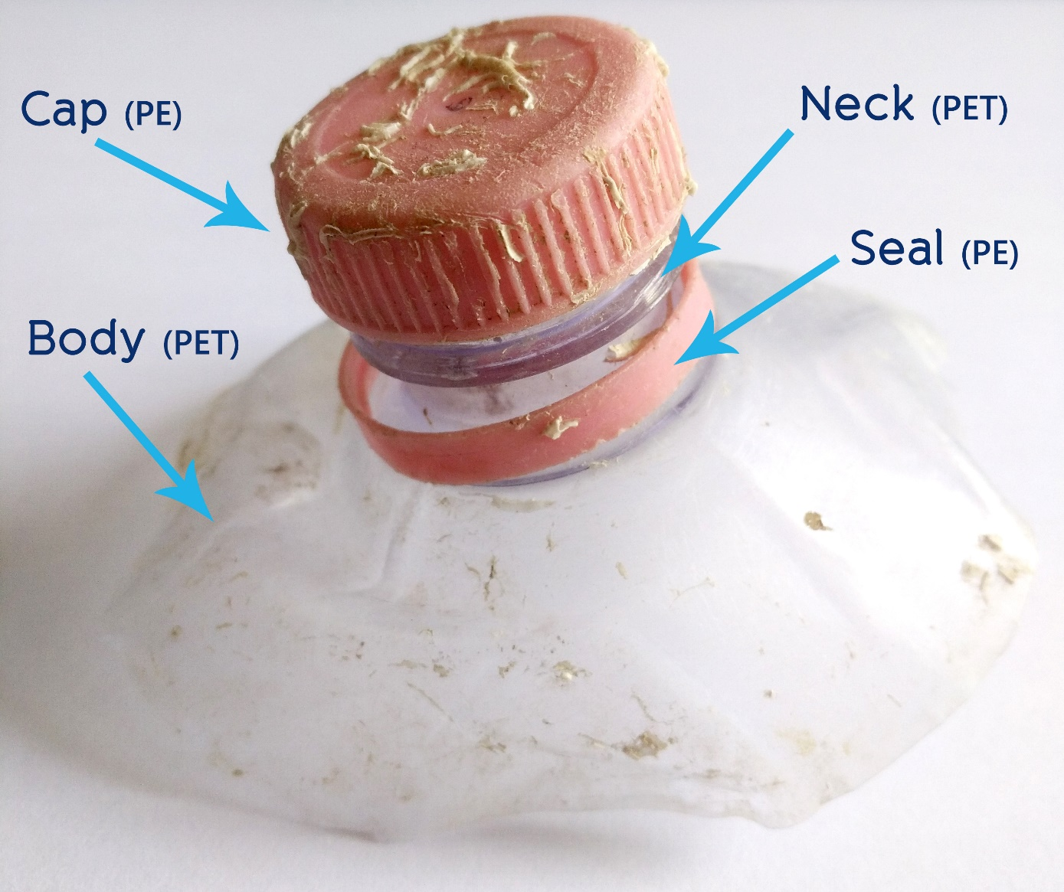
Figure 12: The analyzed sections of the bottles and relative constituting polymer.
110 bottles were collected by PP1 at Chioggia (VE) (Figure 13) from the FfL resulting from the Italian Adriatic coast during different campaigns ranging from July to November 2018, and 58 bottles were taken by PP4 from Croatian Adriatic coast FfL between January and February 2019. The samples were preliminarily cleaned with neutral soap, sodium percarbonate and tap water using slightly abrasive scrubber sponges in order to remove the biofilm from their surfaces (see Deliverable 4.2.5). After cleaning, the samples were subjected to a decalcification and removal of biogenic incrustations. After a visual examination for content expiry date, each bottle was fragmented, choosing, where possible, pieces from body, neck, seal and cap (Figure 13). All generated sub-samples were subjected to a three-day immersion in a citric acid water solution (150g/L) in order to remove the residual calcareous and other deposits to eliminate background confounding signals coming from these materials during surface spectroscopic analysis.

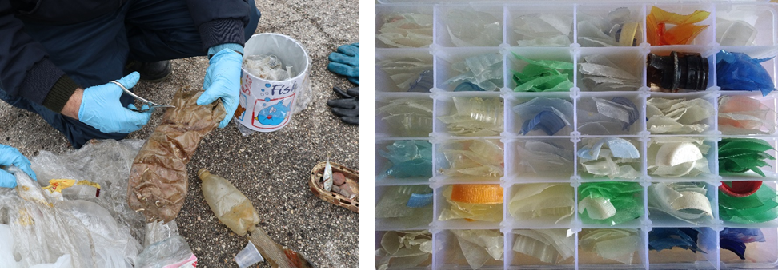
Figure 13: Sampling of bottles collected during FfL activities and the various sections after cleaning ready for spectroscopic analysis

Handheld Near Infrared spectroscopy (NIR) was employed for a fast screening in order to separate PVC bottles and PP caps from the PET and HDPE samples: the remaining samples -the most- were then subjected to FTIR-ATR and Raman spectroscopy investigations; three spectra per side of each of the four fragments of the samples (where present) were collected.

As concerns the results for PET, body samples showed the greatest variability among the fractions, while necks resulted the least altered, especially on the internal side. It is interesting to notice how, by means of both spectroscopic techniques, differences were clearly visible in the spectra of body and neck for both new and ML bottles, this is particularly evident in Raman spectra, in the region between 800 and 1200 cm⁻¹ (Figure 14): these are probably due to a difference in the formation and casting of the two bottle sections. This should be taken into careful account when studying degradation-induced spectral modifications.
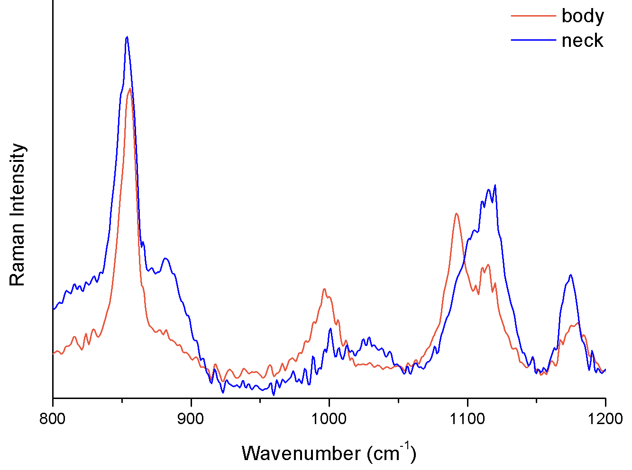
Figure 14: Representative Raman spectra highlighting spectral differences between body and neck sections of PET bottles.
In Figure 15 two representative FTIR-ATR spectra of a new and a ML bottle for the external body surface are shown: the spectral region most involved by spectral modifications is that at higher wavenumbers: in fact, a broad band appears at about 3290 cm⁻¹ in the degraded bottle and can be assigned to carboxylic acid hydroxyl groups.

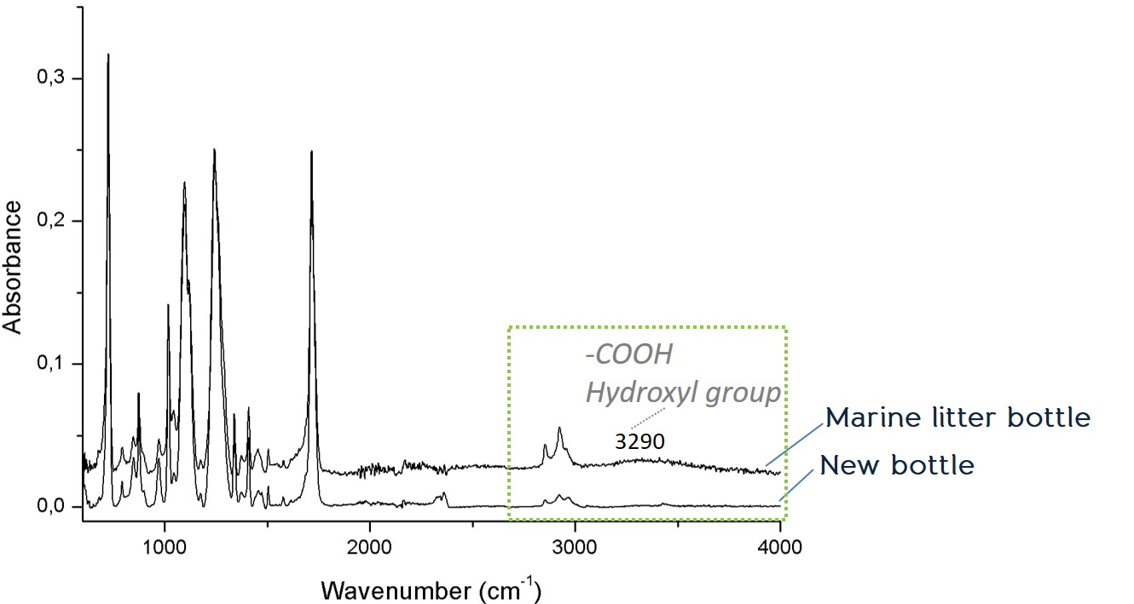
Figure 15: Representative FTIR-ATR spectra of the external side of the body of a new bottle and a marine litter one.
Based on the formation of this band, a Carboxyl End Groups Index, defined as intensity ratio of bands at 3290 and 2970 cm⁻¹, respectively (CEGI= I₃₂₉₀/I₂₉₇₀) was proposed by Fechine et al. 2007 as indicative of PET degradation: in literature, this approach is followed during laboratory weathering experiments, where an increase, with time or with weathering conditions, of the I₃₂₉₀ normalized to a reference signal can be detected [Day & Wiles 1972a, b]. This behaviour is not always and linearly true for real PET samples, as in investigated bottles. Only spectroscopic data generated for the bottles still bearing a readable expiry date were considered for the generation of their CEGI values, which were calculated for both bodies (Figure 16) and necks (Figure 17).

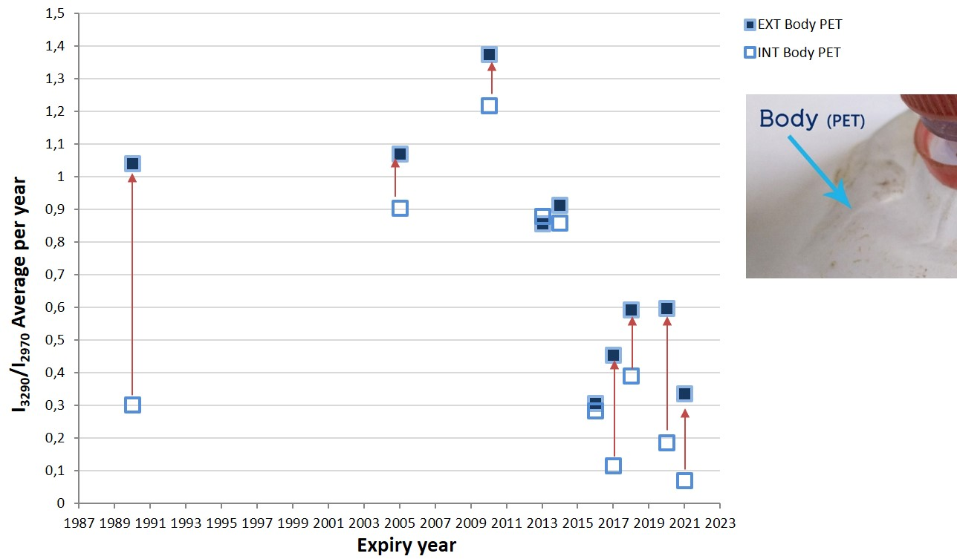
Figure 16: CEGI year average ratios plotted against expiry years of PET bottles body collected in Italian areas; the comparison between external and internal body sides is marked with arrows.
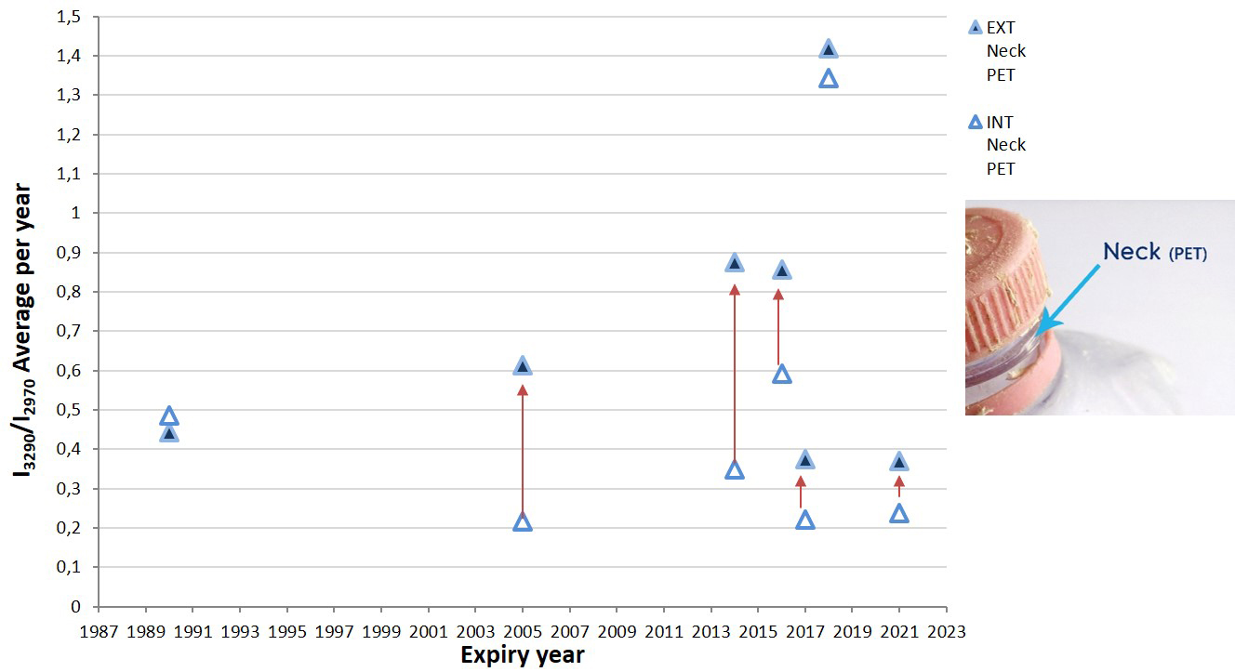
Figure 17: The CEGI year average ratio plotted vs. the expiry years of the Italian bottles; the comparison between the external and the internal sides is marked with arrows.

Notwithstanding the fact that the experimental ratio values do not follow a clear trend with time, it appears evident that, when not very similar, the year average CEGI values calculated for the internal surfaces (body: 0,07-1,22, average = 0,52; neck: 0,22-1,34, average = 0,49) are always lower or much lower than those relative to the external (body: 0,31-1,38, average = 0,75; neck: 0,37-1,42, average = 0,7) bottle sides.

As concerns PE, due to the low number of caps still screwed to bottles with a readable expiry date, and due to the high frequency of seals still retained on bottle necks and easiness of ATR analysis, their external sides were considered.
Figure 18 shows representative FTIR-ATR spectra of PE reference standard, a new bottle seal and a ML one: in the ML seal the appearance of a band at 1000 cm⁻¹, attributable to silicates as well as of new OH group signals at about 3300 cm⁻¹, and the modification at around 1700 cm⁻¹, can be detected. This last feature is considered in literature as indicative of PE degradation [Bonhomme et al. 2003, Cai et al. 2018, Cooper & Corcoran 2010, Gardette et al. 2013, Karlsson et al. 2018, Oldak et al. 2005, Zbyszewsky & Corcoran 2011].
We noticed that signals at 1712 and 1740 cm⁻¹ (Figure 18) are present also on the new bottles spectra, therefore they cannot be simply considered as markers of degradation in the marine environment; on the contrary, they could derive from photo-degradation previously occurred or from mechanical stress induced during the seal production.

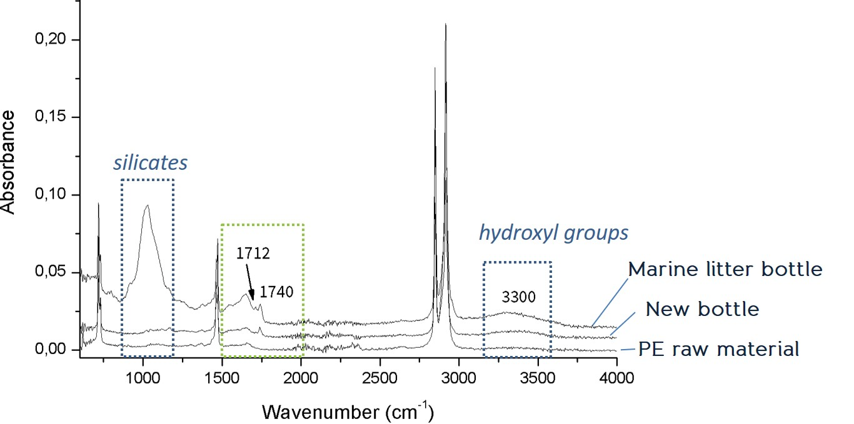
Figure 18: Representative FTIR-ATR spectra of seal external side of a new bottle and a ML one, compared to a PE reference material.
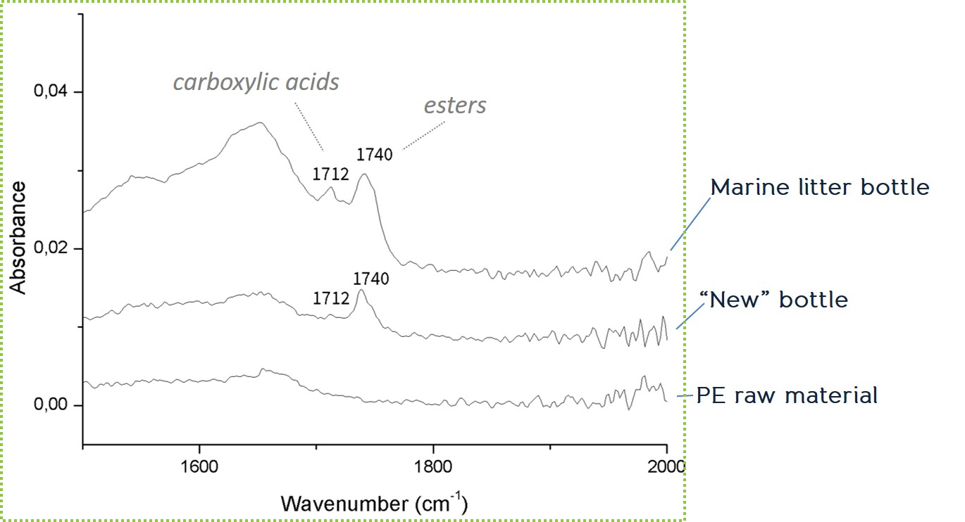
Figure 19: Detail of Figure 18 in the region between 1500 and 2000 cm⁻¹.
When the external surface of seal polyethylene is considered, interesting results related to IR bands linked with PE alteration emerged, i.e. those centered at 1712 (acid groups) and 1741 cm⁻¹ (ester groups), as already known from literature [Karlsson et al. 2018]. It was in fact observed that for older bottles the peak at 1741 cm⁻¹ was increasing with respect to that at 1712 cm⁻¹. Therefore, the ratio of these band intensities, I₁₇₄₁/I₁₇₁₂, was calculated and plotted against the expiry years of the bottles in order to evaluate PE degradation (Figure 20).

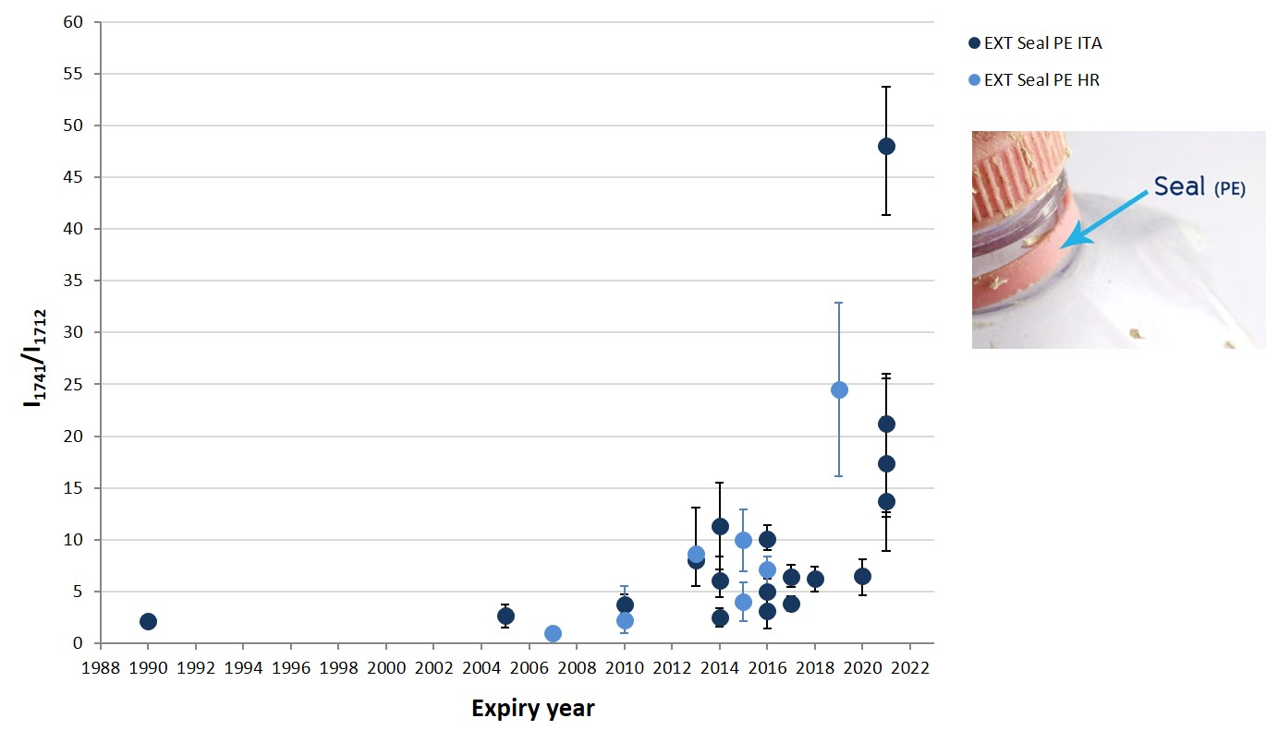
Figure 20: The I₁₇₄₁ / I₁₇₁₂ratio plotted vs. expiry year of Italian and the Croatian bottles seals.

A deconvolution of these bands was, moreover, carried out (Figure 21) in order to take into account only the intensities of the single components involved: an almost linear trend was highlighted plotting the I₁₇₄₁/I₁₇₁₂ ratio of seals with and without band deconvolution (Figure 22), which encouraged to consider the non-deconvoluted bands also for other, non-dated bottles.

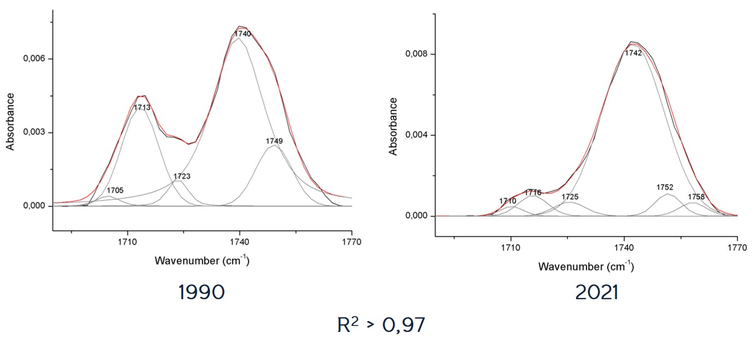
Figure 21: Two typical examples (expiry dates: 1990 and 2021) of deconvoluted FTIR-ATR bands in the spectral region of interest (R²> 0,97 in both cases).

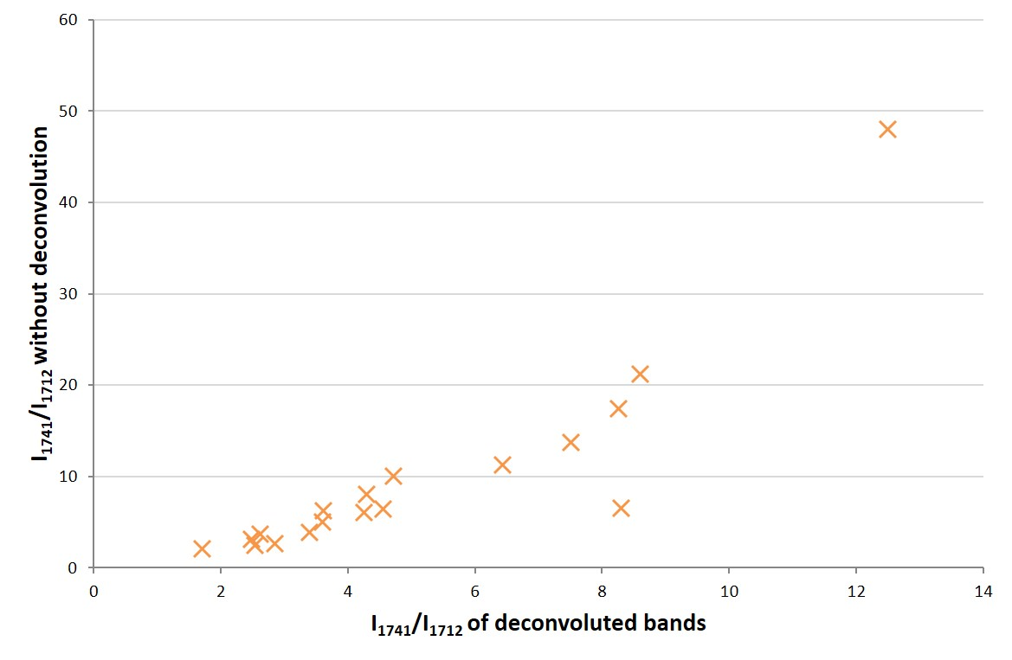
Figure 22: Plot of the I₁₇₄₁/I₁₇₁₂ ratio for external sides of seals found on dated bottles, vs. the corresponding ratios without band deconvolution.
The trend shown in Figure 22, in fact, can be also exploited to evaluate the degree of degradation of non-dated bottles.
Based on the spectroscopic results for all seals on dated bottles collected in Italy and Croatia, three average annual ratio intervals were identified, connected to bottle degradation (but not to the bottle age): Low (ratio<12), Medium (4<ratio<12) and High (ratio<4) degradation extent (Figure 23).

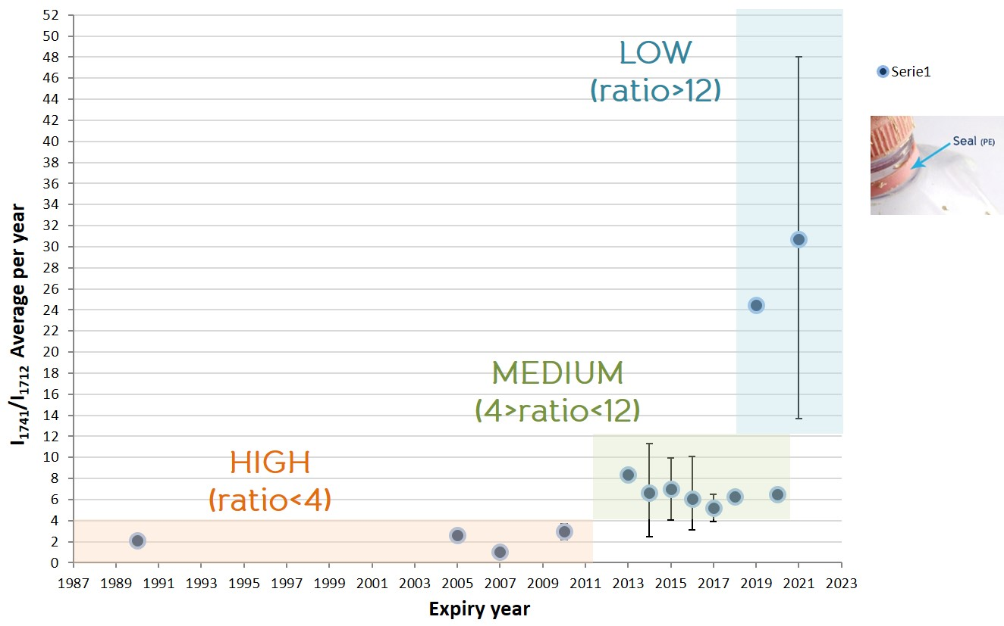
Figure 23: Plot of average I₁₇₄₁/I₁₇₁₂ratio per year as a function of bottle expiry year, and tentative classification of the degradation extent.
Since their I₁₇₄₁/I₁₇₁₂ ratio ,all non-dated bottles could be included in one of the three classes: the results are shown in Figure 24, where the bottles collected in Croatia seem, on the average, more degraded than those collected in Italy.

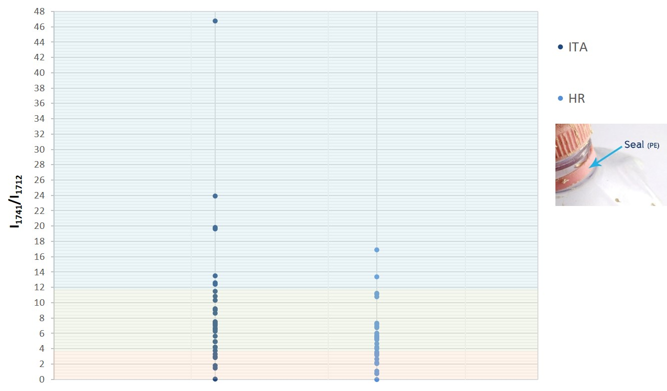
Figure 24: Classification of the degradation extent for seal external side of all Italian and Croatian non-dated bottles investigated, since theirI₁₇₄₁/I₁₇₁₂ ratio values.
The FTIR-ATR analyses proved suitable for the investigation of both PET and PE degradation in the marine environment, whilst Raman spectroscopy exhibited some limits, such as fluorescence and background noise, especially for more degraded bottles and/or coloured ones (Figure 25).

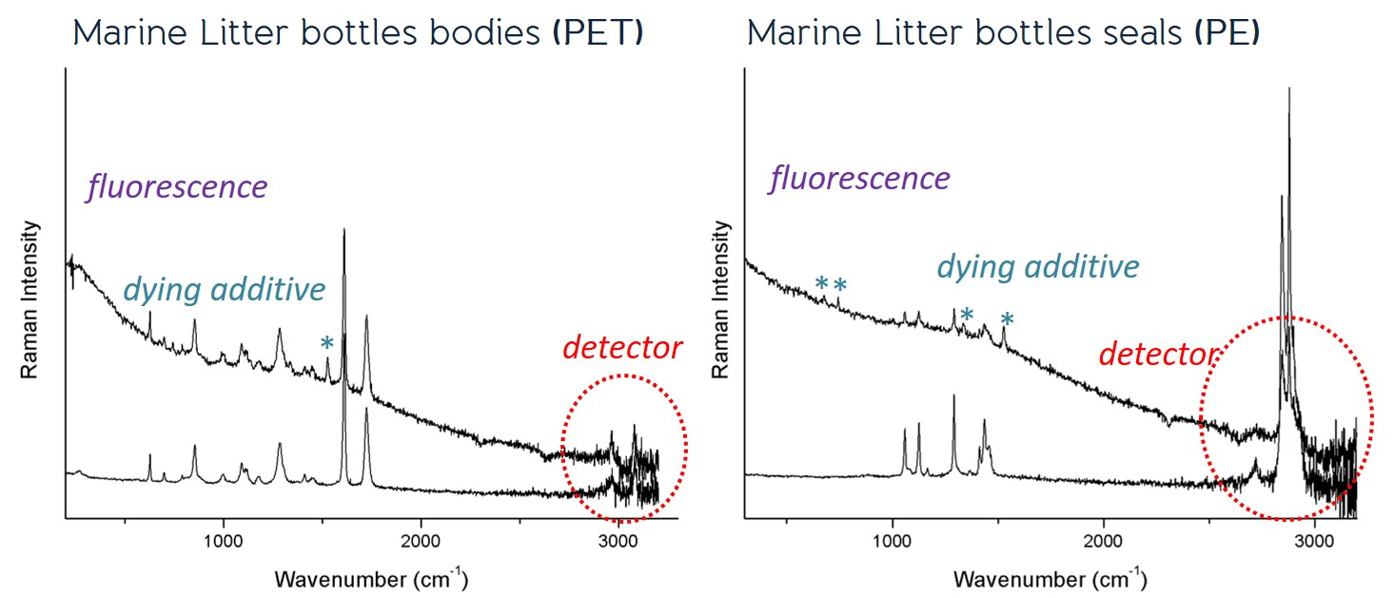
Figure 25: Representative Raman spectra of ML bottle bodies (PET) and seals (PE), various technical issues arising from the instrumentation or from the sample are highlighted.
In conclusion, it can be stated that:
- different PET sections of bottles can exhibit different IR and Raman spectra, so, when studying the spectral differences due to degradation, this must be considered;
- the CEGI index calculated on PET sections from ML bottles shows a lower degradation on the interior sides, even if no clear trend was highlighted, since real samples can be subjected to variable environmental exposition;
- new PE seals already show bands normally attributed by the literature to polymer alterations;
- the ratio I₁₇₄₁/I₁₇₁₂ for PE seals seems to follow a trend with time which allowed to arrange non-dated bottles into three different degradation classes.

- References

Bonhomme S., Cuer A., Delort A-M., Lemaire J., Sancelme M., Scott G., Environmental biodegradation of polyethylene, Polymer Degradation and Stability 81 (2003) 441–452.

Cai L., Wang J., Peng J., Wu Z., Tan X., Observation of the degradation of three types of plastic pellets exposed to UV irradiation in three different environments, Science of the Total Environment 628–629 (2018) 740–747.

Cheshire, A.C., Adler, E., Barbière, J., Cohen, Y., Evans, S., Jarayabhand, S., Jeftic, L., Jung, R.T., Kinsey, S., Kusui, E.T., Lavine, I., Manyara, P., Oosterbaan, L., Pereira, M.A., Sheavly, S., Tkalin, A., Varadarajan, S., Wenneker, B., Westphalen, G. (2009). UNEP/IOC Guidelines on Survey and Monitoring of Marine Litter. UNEP Regional Seas Reports and Studies, No.186; IOC Technical Series No. 83

Cooper D.A., Corcoran D.L., Effects of mechanical and chemical processes on the degradation of plastic beach debris on the island of Kauai, Hawaii, Marine Pollution Bulletin 60 (2010) 650–654.

Day M., Wiles, D.M., Photochemical Degradation of Poly(Ethylene Terephthalate) I. Irradiation Experiments with the Xenon and Carbon Arc, Journal of Applied Polymer Science, 16, (1972), 175-189.

Day M., Wiles, D.M., Photochemical Degradation of Poly(Ethylene Terephthalate) II. Effect of Wavelength and Environment on the Decomposition Process, Journal of Applied Polymer Science, 16, (1972), 191-202.

Fechine G.J.M., Souto-Maior R.M., Rabello M.S., Photodegradation of Multilayer Films Based on PET Copolymers, Journal of Applied Polymer Science 104, (2007) 51–57.

Gardette M., Perthue A., Gardette J.-L., Janecska T., Földes E., Pukánszky B., Therias S., Photo- and thermal-oxidation of polyethylene: Comparison of mechanisms and influence of unsaturation content, Polymer Degradation and Stability 98 (2013) 2383-2390.

Hanke, G., Galgani, F., Werner, S., Oosterbaan, L., Nilsson, P., Fleet, D., Kinsey, S., Thompson, R., Palatinus, A., Van Franeker, J.A., Vlachogianni, T., Scoullos, M., Veiga, J.M., Matiddi, M., Alcaro, L., Maes, T., Korpinen, S., Budziak, A., Leslie, H., Gago, J., Liebezeit, G., 2013. Guidance on Monitoring of Marine Litter in European Seas (EUR - Scientific and Technical Research Reports). Publications Office of the European Union. https://doi.org/10.2788/99475 (pdf)

Karlsson T.M., Hassellöv M., Jakubowicz I., Influence of thermo-oxidative degradation on the in situ fate of polyethylene in temperate coastal waters, Marine Pollution Bulletin 135 (2018) 187–194.

Oldak D., Kaczmarek H., Buffeteau T., Sourisseau C., Photo- and bio-degradation processes in polyethylene, cellulose and their blends studied by ATR-FTIR and Raman spectroscopies, Journal of Materials Science 40 (2005) 4189 – 4198.

Zbyszewski M., Corcoran P.L., Distribution and Degradation of Fresh Water Plastic Particles Along the Beaches of Lake Huron, Canada, Water Air Soil Pollution 220 (2011)365–372.

